- A student does an experiment to find the mass of a metre rule.
  - A fixed mass is placed on the metre rule at the 5.0cm mark as shown in Fig. 3.1.
metre rule

mass fixed at 5.0cm

The student:

25.0cm

pivot bench

Fig. 3.1

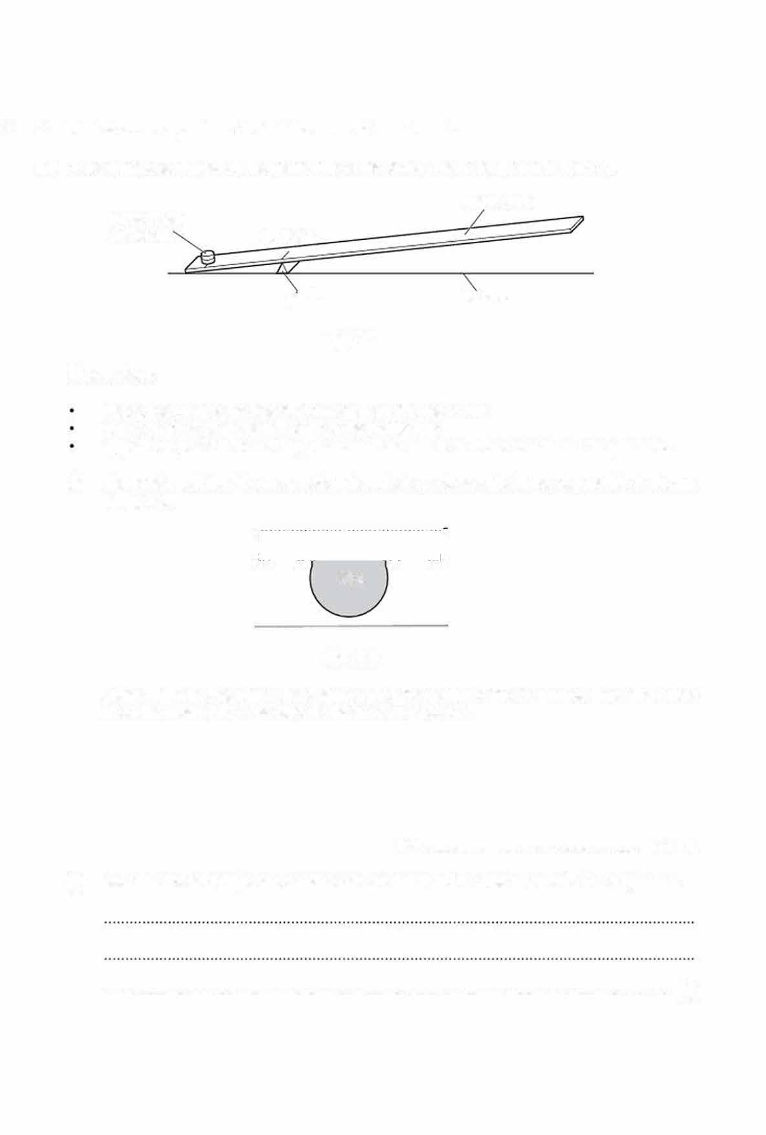
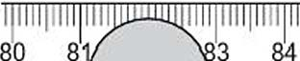
places the pivot below the 25.0cm mark on the metre rule places a mass of mass m = 20g on the metre rule
adjusts the position of the 20g mass until the rule is as close to balance as possible.

- The position of the 20g mass when the rule is as close to balance as possible is shown in Fig. 3.2.

20g

Fig. 3.2
Using Fig. 3.2, determine the distance d of the centre of the 20g mass from the pivot
when the metre rule is as close to balance as possible.

d = ................................................... cm [1]
- Describe the technique the student uses to balance the metre rule with the 20g mass.

. [1]

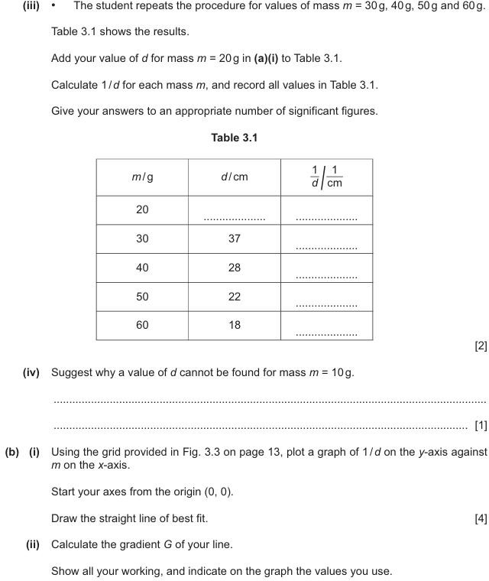



(c) The mass M of the metre rule can be calculated using the equation:
M = 160- 0.0G40
Use your value of Gin (b)(ii) to calculate M.

(d)

M= .... g(1]

mass fixed modelling clay
at .0c
5
-=..c.
...ccc c.c
--(cf
--
/
':c@
m
�
,
2 o
c
m
r1q...

�pivot ""metre rule Fig. 3.4
TFihge. s3t.u4d. eHnet ifsingdsivethnata tphieecmeeotrfemrouldeelilsinbgaclalanyc.eHdewphlaecnetsheit on the metre rule as shown in

40.0 cm fro

m the pivot.
modelling clay is a distance of

yUosuinrgwyoorkuirng.raph in Fig. 3.3 on page 13. find the mass of the piece of modelling clay. Show

mass of piece of modellirg clay = ...................................................... g [2]
[Total: 14]


- A student uses ice cubes to investigate the time taken for different masses of ice to melt when the ice cubes are placed in water.

Plan an experiment using ice cubes to investigate how the mass of ice affects the time taken for the ice to melt

The following apparatus is available:

top pan balance supply of ice cubes 250 cm3 beaker supply of cold water stopwatch
You may also use other apparatus and materials that are usually available in a school laboratory. In your plan, you should:
explain briefly how to do the investigation state the key variables to keep constant
draw a table, with column headings, to show how to display readings (you are not required to enter any readings in the table)
explain how to use these readings to reach a conclusion.

You do not have to include a diagram of the apparatus you use but you may do so if it helps your plan.

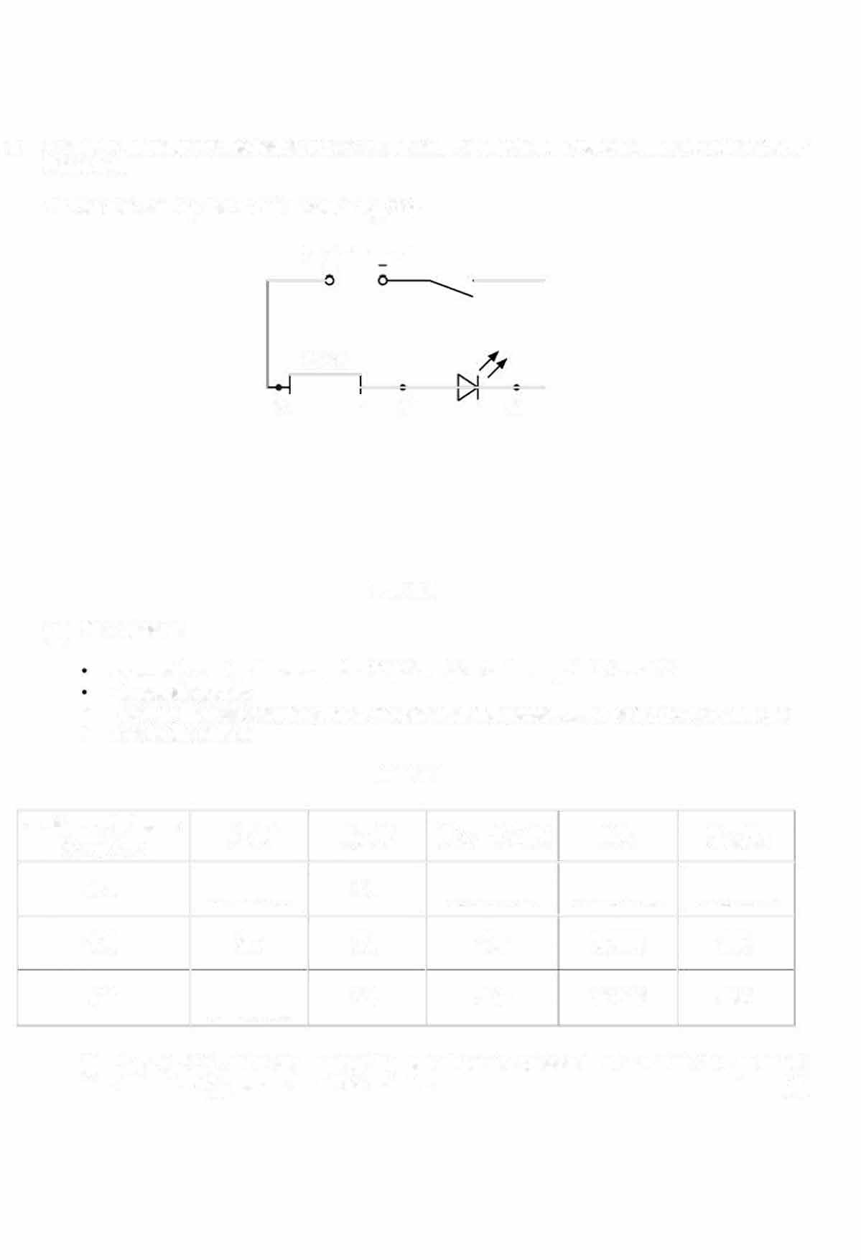
- A student investigates the resistance of a light-emitting diode (LED) when different currents flow through it.

The student sets up the circuit shown in Fig. 2.1 .
power source
+

270Q
x'-----' y z

Fig. 2.1
  - The student:
connects a voltmeter across the 270Q resistor between points X and Y
    - closes lthe switch
records the voltmeter reading of the potential difference Vxy in the top row of Table 2.1 opens the switch.
•

Table 2.1

resistance between X and Y/Q | Vxy lV | Vy2IV | (Vxv + Vyz)IV | I/A | RLED/Q
270 | ........ ,, ....... | 2.1 | . ' .. | ..........' ....... | .................
470  560 | 2.6  ••••••••••••••••• | 2.0  2.0 | 4.6  4.6 | 0.0053  0.0046 | 380  430

(I) On Fig. 2.1, draw the symbol for a. voltmeter connected to measure the potential difference Vxv across the 270Q resistor. (1]

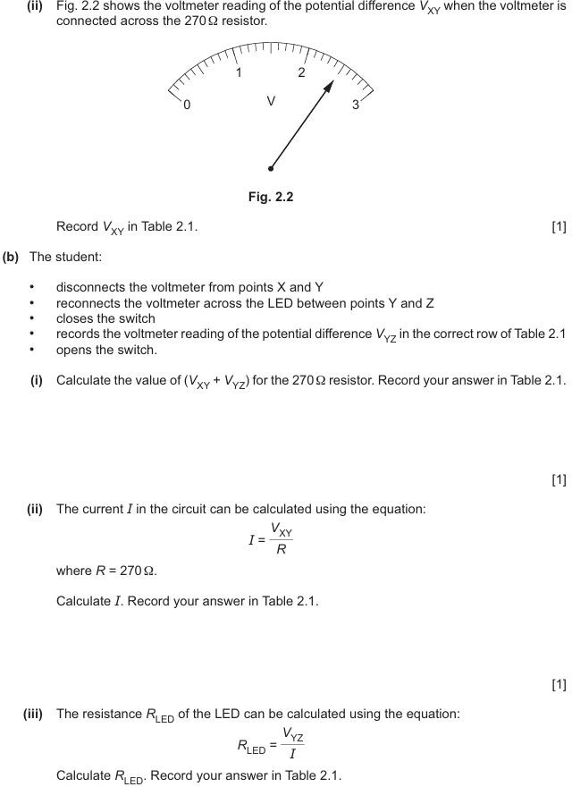

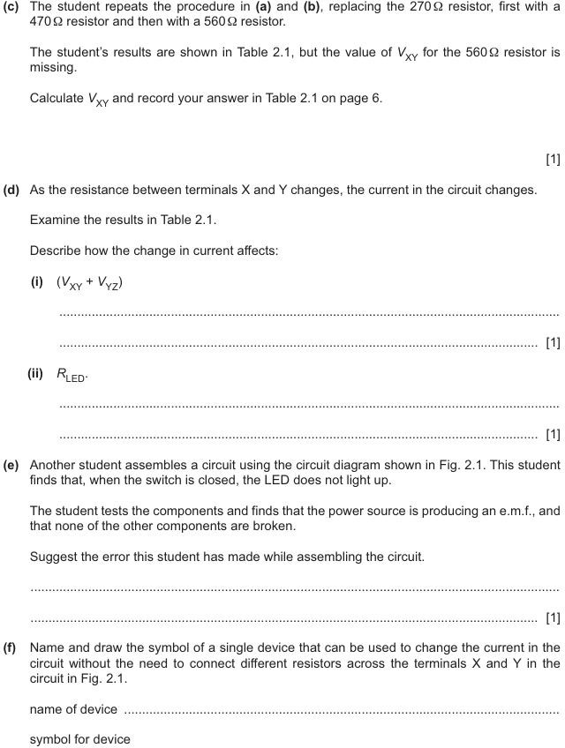

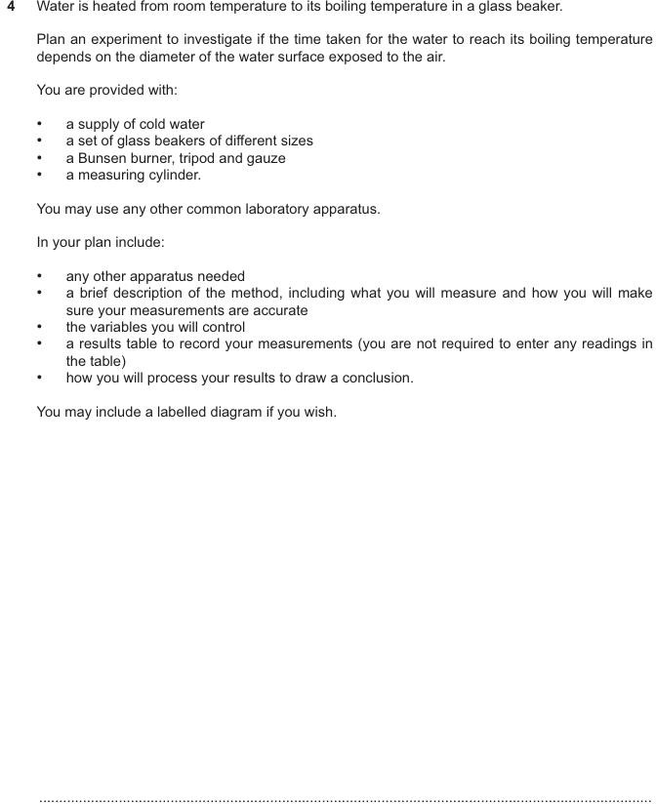

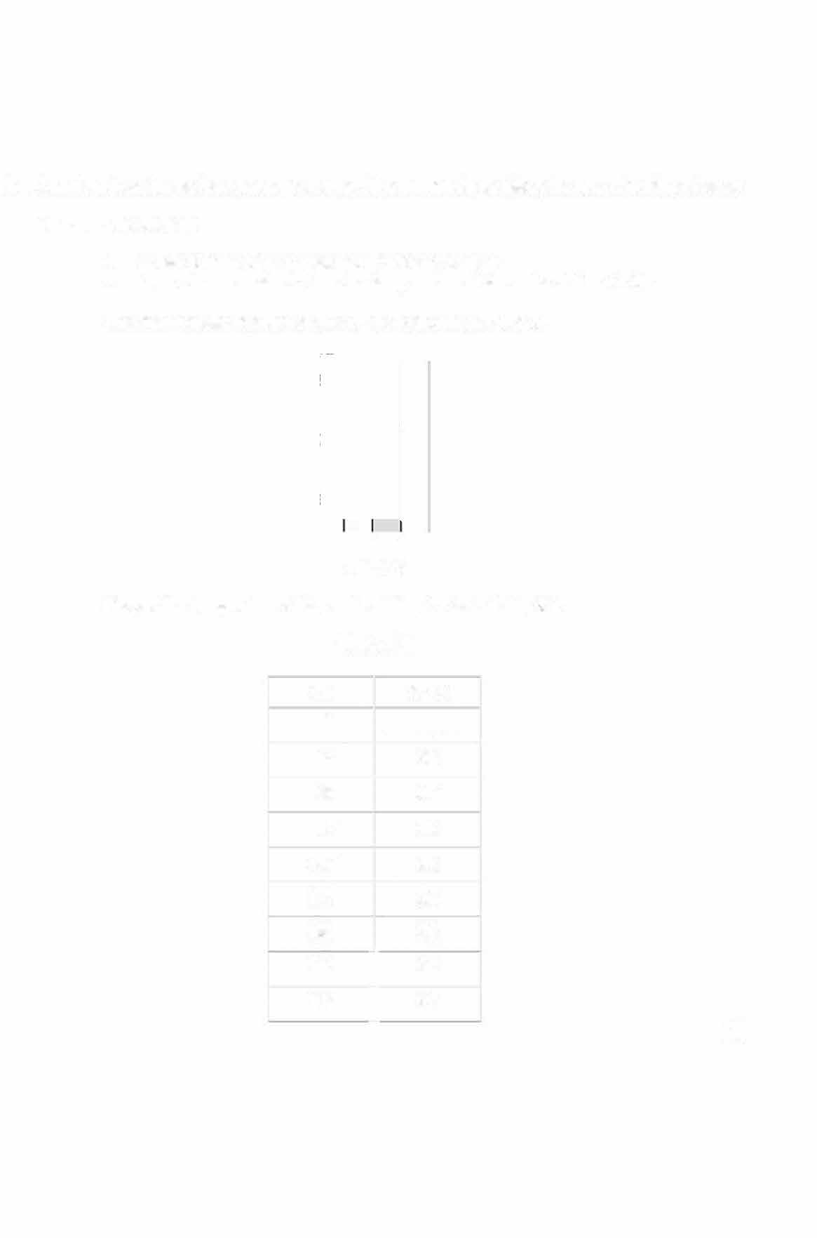
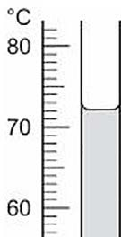
- A student investigates how the temperature of the surroundings affects the rate of cooling of water.
  - (i) The student:
    - pours 100cm3 of hot water into a 250cm3 beaker
    - uses a thermometer to take the temperature of the water at time I = 0s.

The thermometer reading at time t = Os is shown in Fig. 2.1.

Fig. 2.1

Record the temperature of the water at time t = Os in Table 2.1.

Table 2.1

tis | 01•c
0 | ...................
30 | 69
60 | 67
90 | 66
120 | 65
 | 64
180 | 63
210 62
I
240 61
11)
150

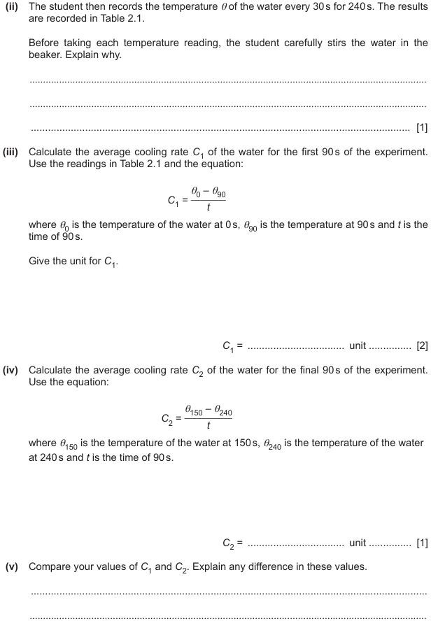

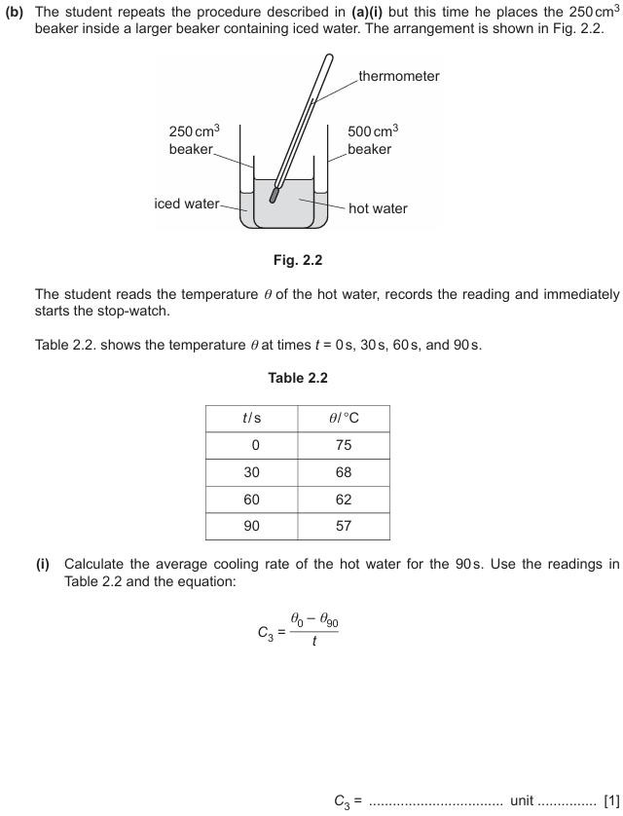

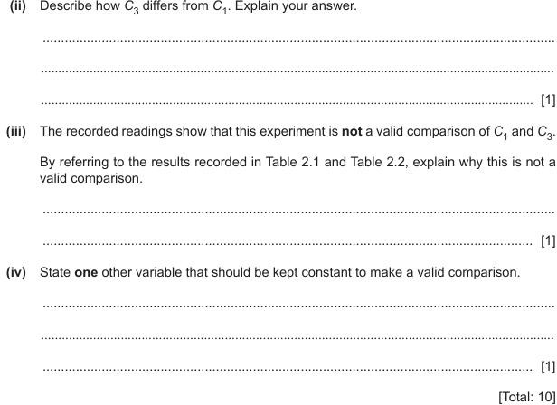

- A student has a converging (convex) lens and needs to determine its focal length.
Plan an experiment that will enable the student to measure an accurate value for the focal length f
of the lens.
The focal length f of a lens can be calculated using the equation:
₌ ....!!!......
f
u+v
where u is the distance between an object and the lens and vis the distance between the focussed image of the object and the lens.
Fig. 4.1 shows some of the apparatus available. triangular object hole cut into a piece of card
lamp card converging lens

to power
lens holder bench

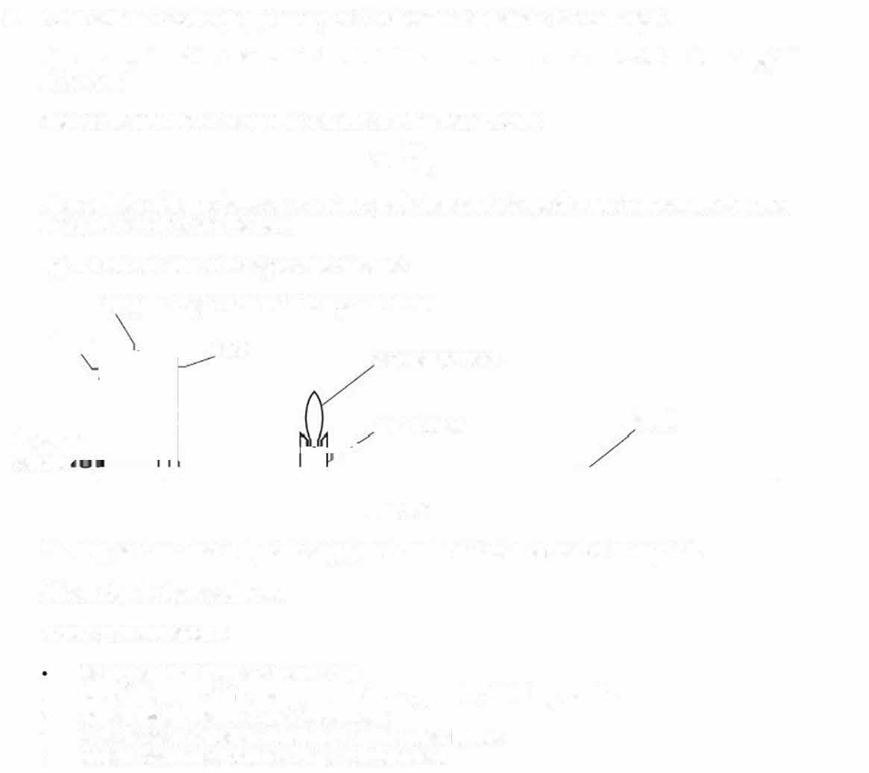
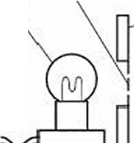
supp...:..ly ..:..::CL---L.LL---- ---L --'-

Fig. 4.1

The lamp is connected to a power supply and can be switched on and off as required. Write a 1Plan for the experiment.
In your plan you should:
list any additional apparatus needed
- draw a diagram of the arrangement of the apparatus, labelling u and v
- explain briefly how to do the experiment
- state the steps taken to obtain a sharp, focussed image
- explain how to use your readings to determine f.

- A student determines the speed of a wavefront on the surface of water.
The student fills a plate with water and uses a dropping pipette to let one drop of water fall into the cerntre of the plate as shown in Fig. 1.1.

dropping pipette

water
---.....___
wavefront

plate

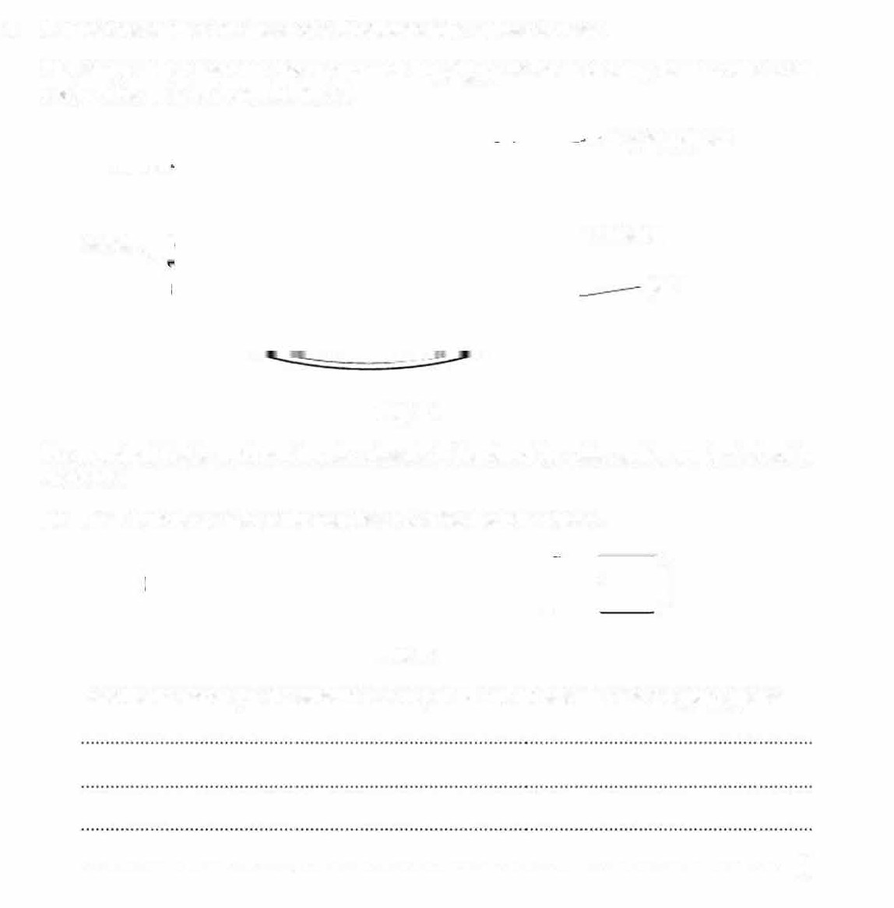
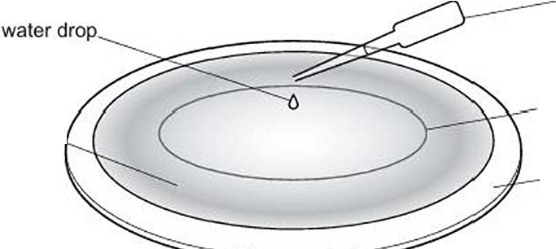
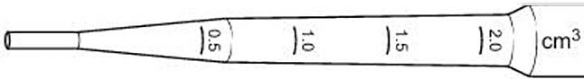

Fig. 1.1

The wavefront that is produced travels outwards to the rim of the plate and then reflects back to the centre.

  - Fig. 1.2 shows a scale marked on the side of the dropping pipette.
)
Fig.1.2

Describe the technique the student uses to put 1.0cm3 of water into the dropping pipette.

. [3]

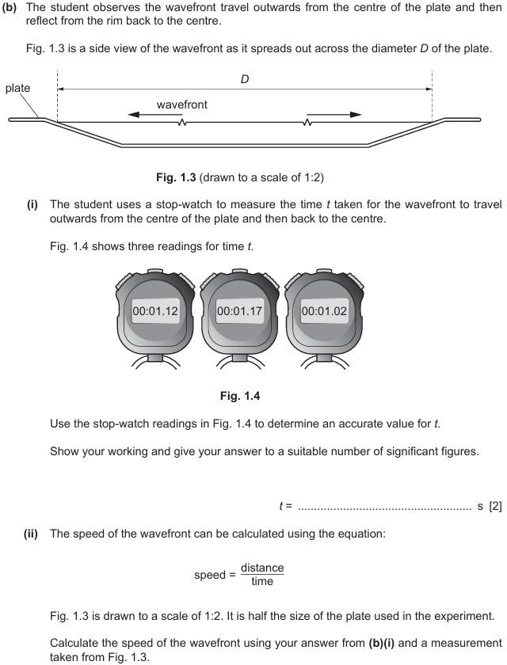


(c) (i)
Identify two causes of uncertainty in this experiment.

1 ........................................................................................................................................
2 ........................................................................................................................................
(2]
(ii) Suggest one improvement that could be made to this experiment.
. I1 J
[Total: 10]

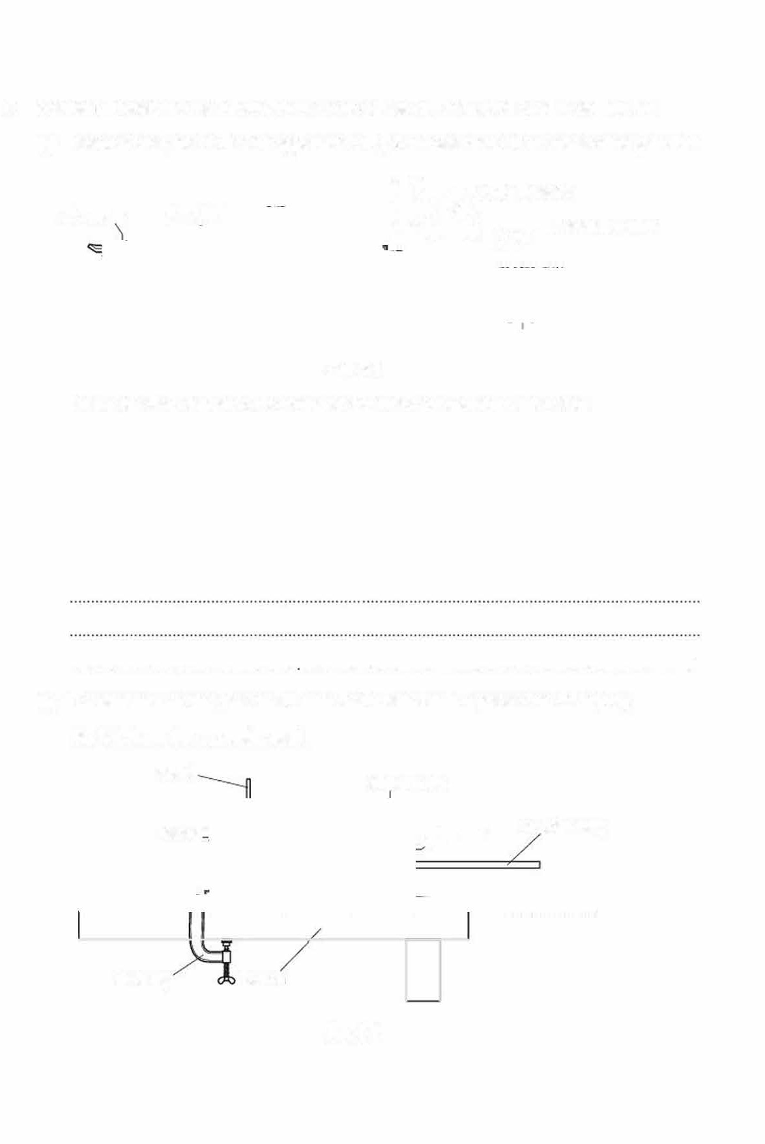
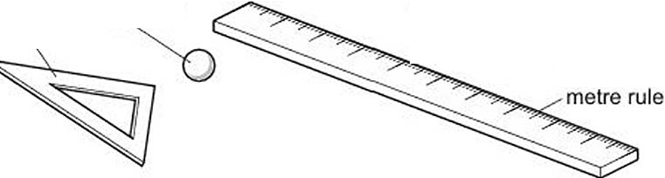
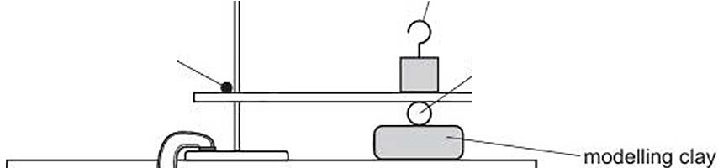
- A student investigates the indentation made by a glass ball in the surface of modelling clay.
  - Describe briefly how to use the apparatus in Fig. 3.1 to determine the diameter of the glass ball.
we
ffi----;100 g masses
set square glass ball
0--adhesive putty

Fig. 3.1
Draw a labelled diagram of the arranged apparatus to help your explanation .

........................ .........······. [2]
  - The student uses the glass ball to make an indentation in a piece of modelling clay. Fig. 3.2 shows the apparatus used.
stand 300g mass

clamp glass ball wooden strip

G-clamp bench

Fig. 3.2

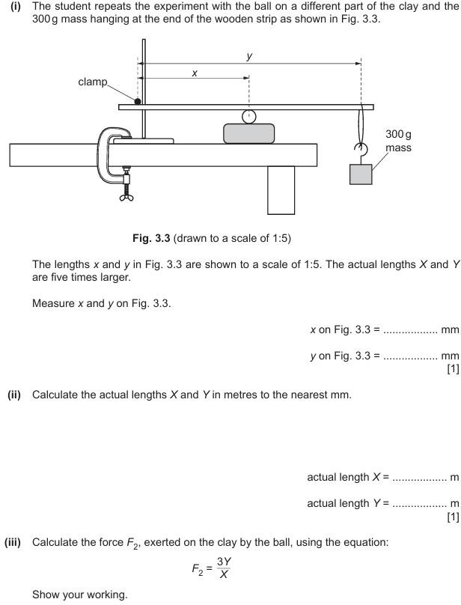

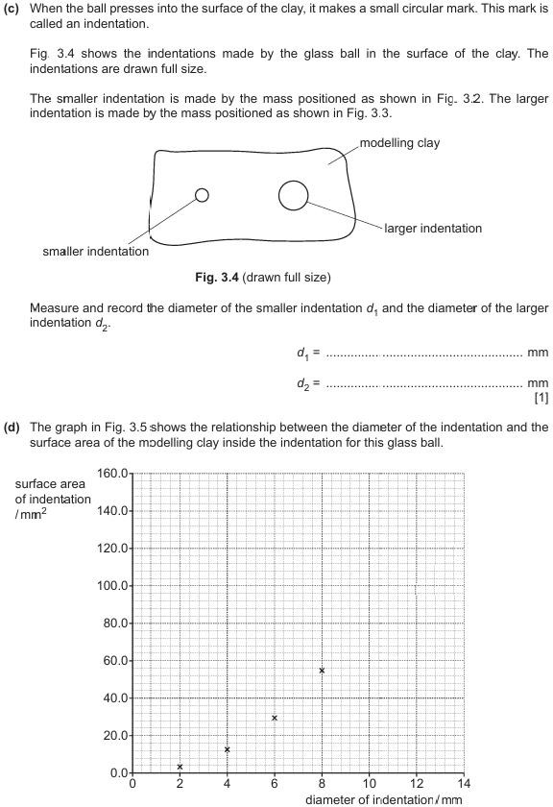

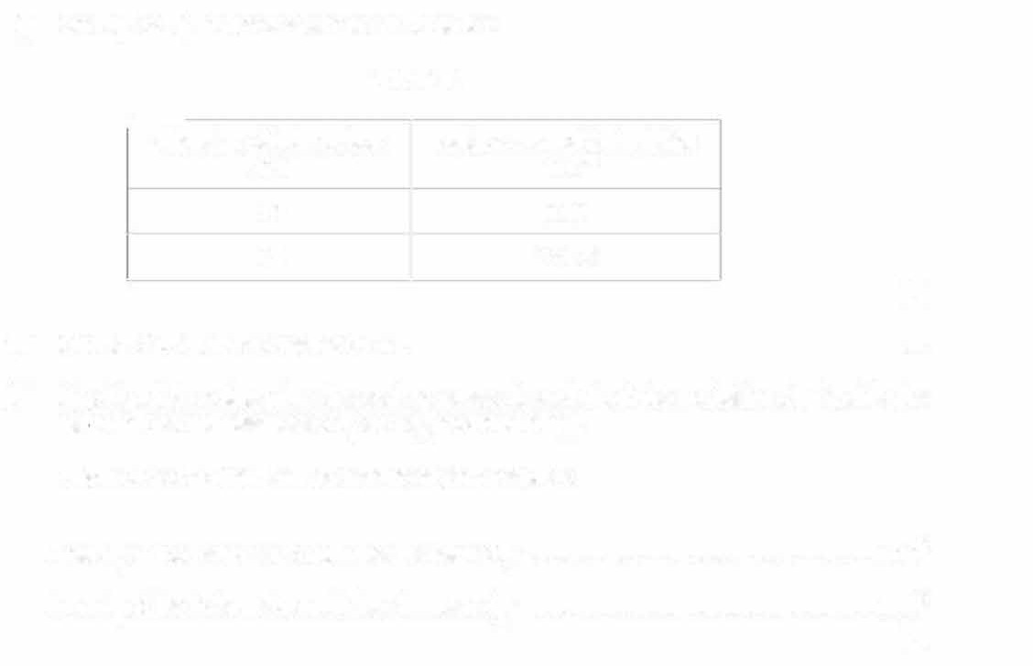
(i) On Fig. 3.5, plot the data shown in Table 3.1.
Table 3.1
�
(ii)

(iii)
On Fig. 3.5, draw the best-fit curve.
[1]

[1]
Use Fig. 3.5 to determine the surface areas A₁ and A2 of the modelling clay inside the indentations with diameters d₁ and d2 recorded in (c).
Show on your graph how you arrive at your answers.
Area A₁ of the indentation with the diameter d₁ = mm2
Area A2 of the indentation with the diameter d2 = mm2
(1]

diameter of indentation  Imm  10 | surface area of indentation  /mm2  90.0
12 | 141.3

- Another student claims that:
where k is a constant. F₁ = 3.0 N and F2 is your answer to (b)(iii).
  - Using your values of F2, A₁ and A₂ from (b)(iii), and (d)(iii), calculate two values of k.
Record your answers to a suitable number of significant figures.

first value of k = ...............................................................
second value of k = ...............................................................

[2]

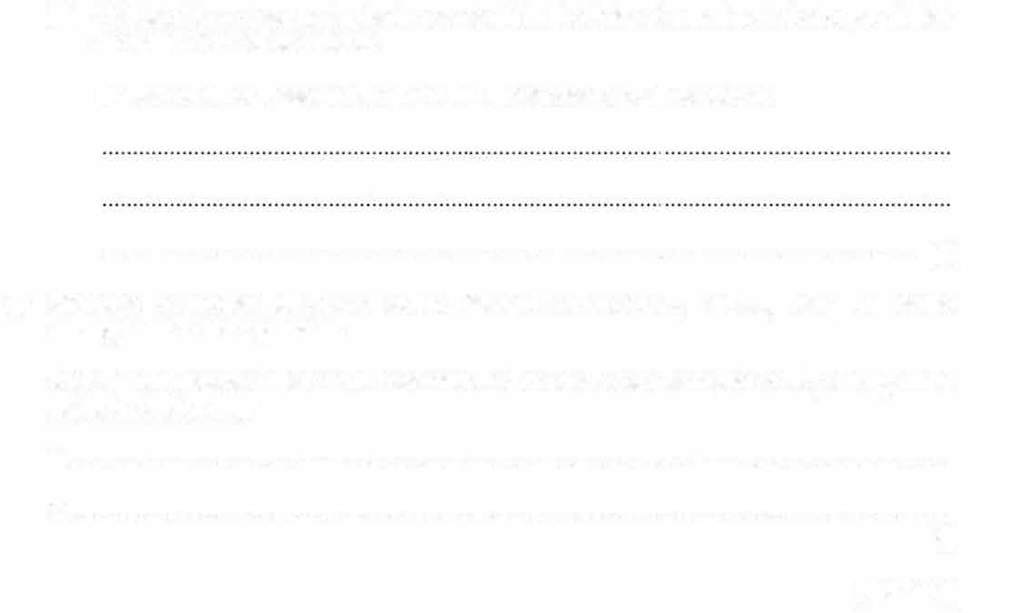
  - Values of k are assumed to be the same within the limits of experimental accuracy if they are within 10% of each other.
Explain whether these results show that the student's claim is correct.

. [1]
- Students in another laboratory obtain different values of A₁ and A₂ using the same arrangement of the apparatus.
Identify two variables that should be controlled to ensure similar values of A₁ and A₂ when using modelling clay.
- ................................................................................................................................................
- ................................................................................................................................................
[2]
[Total: 14]

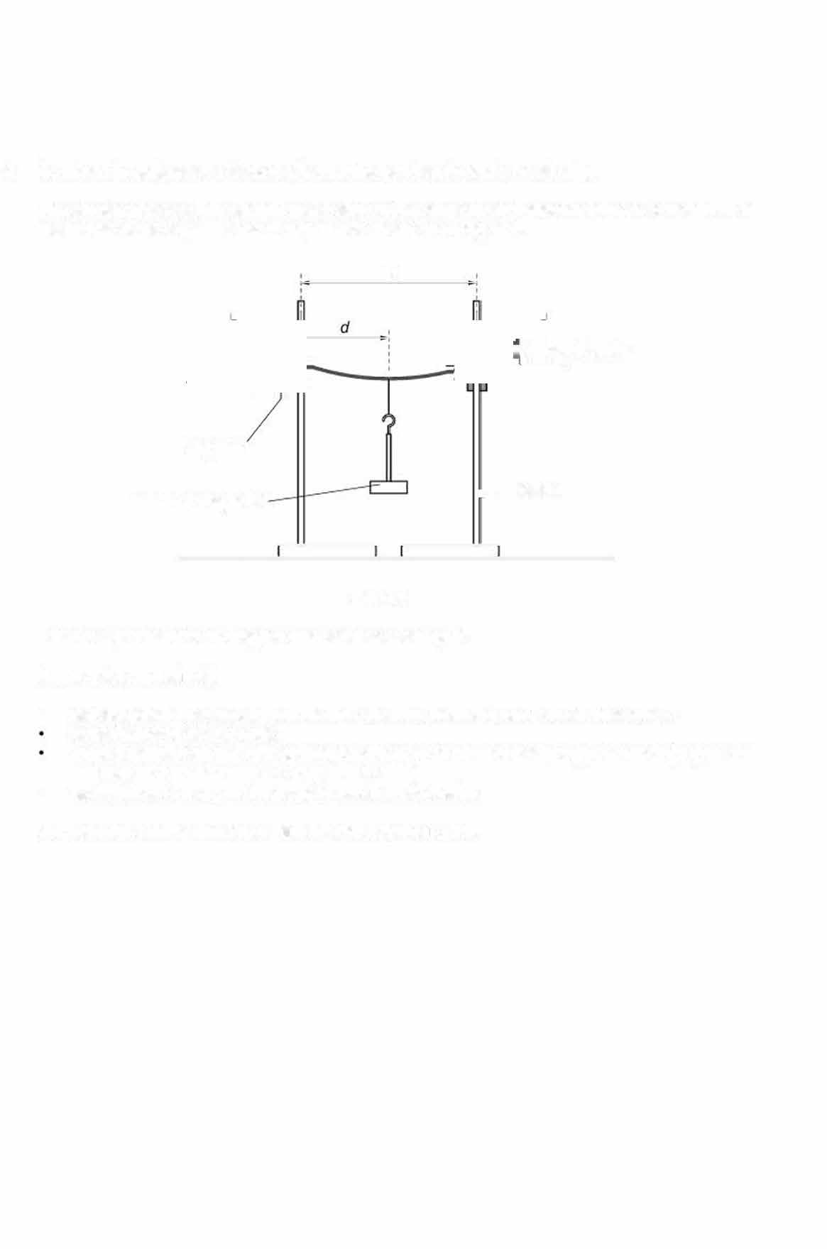
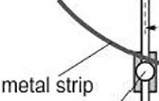
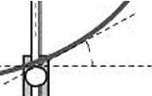
- A student investigates the factors affecting the bend angle 0 of a metal strip.
The student places a thin, straight metal strip on two supports and attaches a mass of weight Wto the middle of the strip. The metal strip bends as shown in Fig. 4.1.

D

o bend angle

support

mass of weight W , stand

Fig. 4.1

Plan an experiment to investigate one variable affecting 0.
In your plan, you should:
- explain briefly how to carry out the investigation, including how you will measure 0
state the variables to control
draw a table, or tables, with column headings, to show how to display your readings (you are
not required to enter any readings in the table}
- explain how to use your readings to reach a conclusion.
You may draw a diagram if you think this will help your plan.

- A student investigates the rate of cooling of waler at the top and at the bottom of a beaker of hot water.
  - The student:
measures the room temperature 0R as OR = 22.5 •c pours 200cm3 of hot water into a beaker
lowers a thermometer into the beaker until its bulb is just covered by the hot water, as shown in Fig. 2.1

thermometer-_.:ljl=⁷;?=

--
water--;-
11--- stand

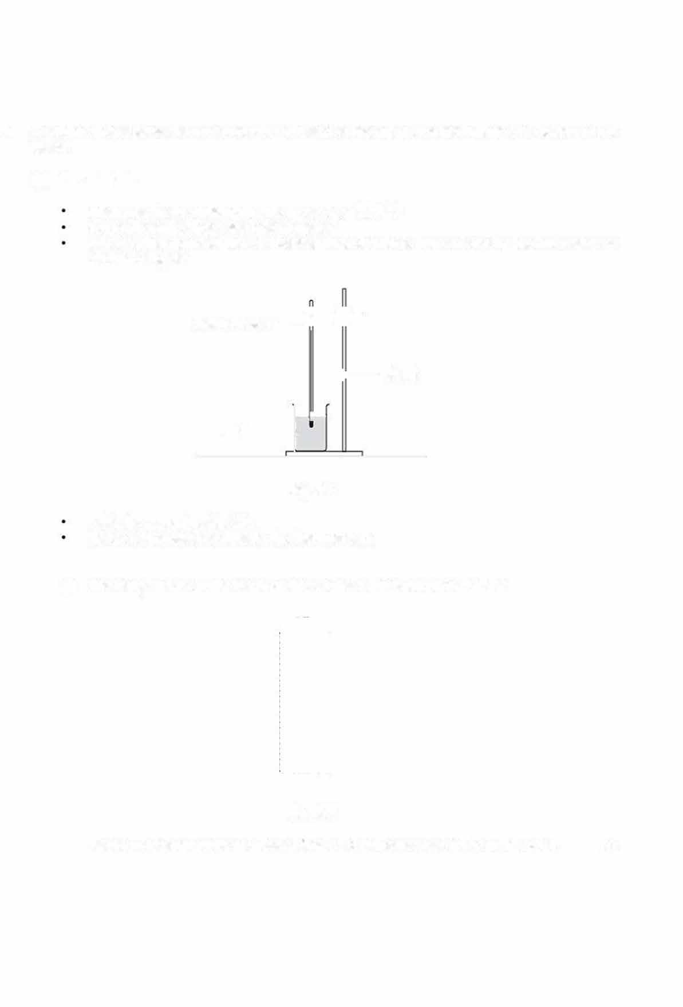
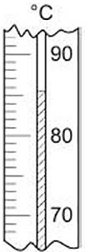

Fig. 2.1
waits for approximately 30s
starts a stop-watch and reads the thermometer.

- The temperature on the thennometer at time t = 0 is shown in Fig. 2.2.

Fig. 2.2
Record the temperature reading at time I= Oto the nearest 0.5°C in Table 2.1. (1]

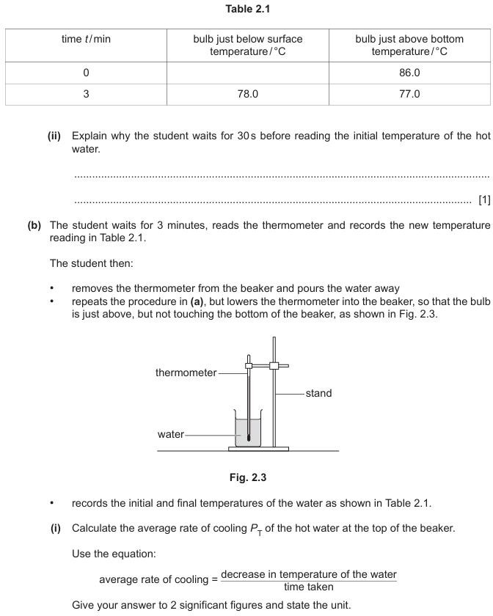


- Use the data in Table 2.1 on page 7 to calculate the average rate of cooling P8 of the hot water at the bottom of the beaker.

P8 = [1]
- (i) Use your answers to (b)(I) and (b)(li) to suggest why a hot liquid should be stirred before measuring its temperature.

. [1]
(ii) State one way in which the apparatus in this experiment is arranged to make it easy to read the thermometer accurately.

. I1 J
- The experiment is repeated to check the results.

Suggest one variable that must be kept constant.
. (1]

- The student leaves the thermometer in the hot water and waits for 30 minutes before reading the thermometer again.

Predict a value for the temperature of the water in the beaker.
temperature of water= .................................................... •c (1]
[Total: 10]

- A student investigates how the potential difference V across the terminals of a power supply changes as the current I in a circuit changes.
The student assembles the circuit shown in Fig. 3.1.
,----------1 V --,

power supply

A insulating tape flying lead

10 20 30 40 50 60 70 80 90 100

resistance wire

crocodile clip

Fig. 3.1

  - The student closes the switch and observes the reading V0 on the voltmeter. The reading is shown in Fig. 3.2.

0 3

Record the voltmeter reading V₀.

  - The student then:
Fig. 3.2

V₀ = ...................................................... V (1]

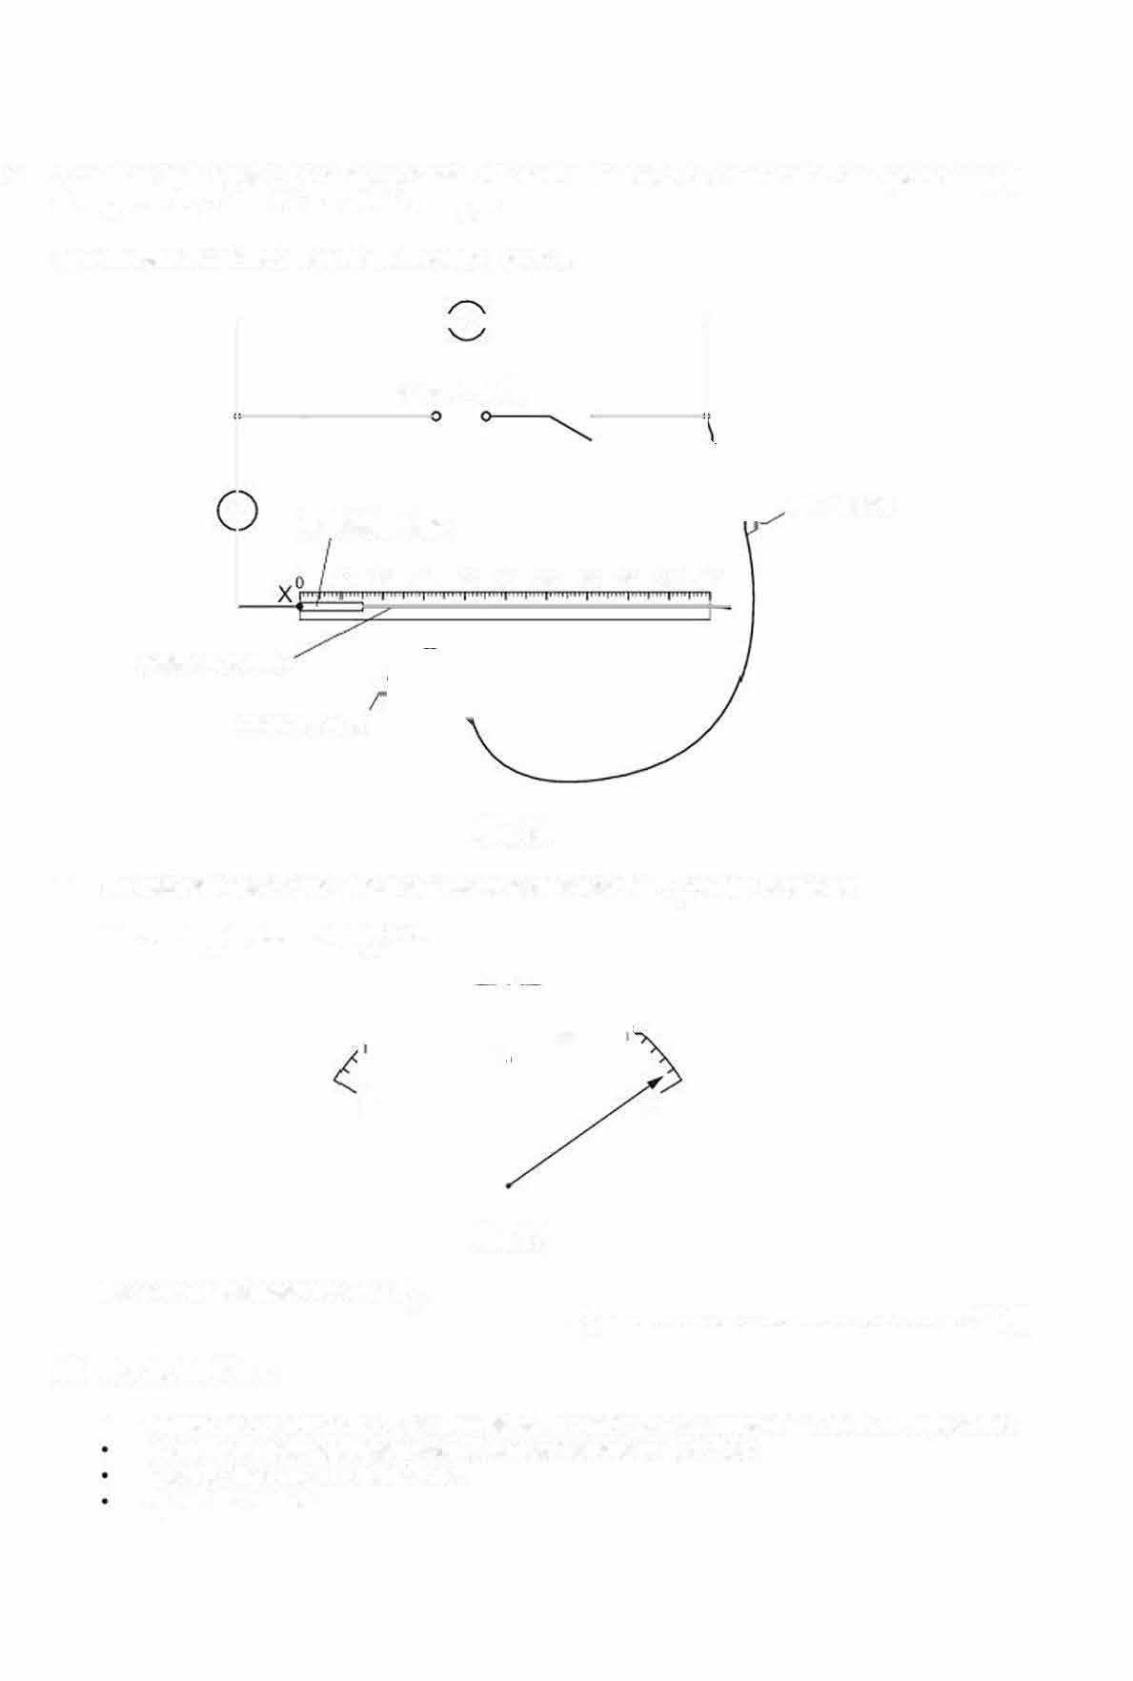
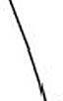
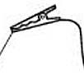
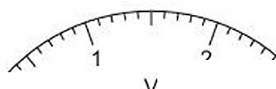
    - connects the crocodile clip to the resistance wire at a distanced= 100.0cm from end X records the potential difference V across the wire as V = 2.3-V
records the current I in the wire opens the switch.

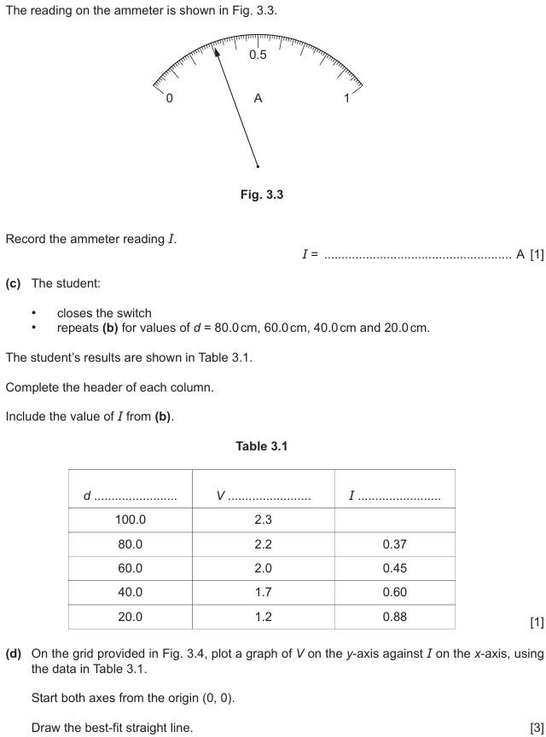

V/V


I/A

Fig. 3.4


- (i) The gradient m of your line is numerically equal to the resistance r of the power supply. Calculate the gradient of your line.
Show clearly on the graph the values you chose and show your working.

m = [2]
(ii) The intercept between the y-axis and your line is the electromotive force V₀ of the power supply.
Extend your best-fit line to meet the y-axis and write down the value of V₀.
V₀ = ...................................................... V [1]

- Compare the value of V₀ in (a) with the value of V₀ you obtained from the graph in (e)(ii).
Two quantities can be considered to be equal within the limits of experimental accuracy if their values are within 10% of each other.
State whether your results show that the two values obtained for the electromotive force are the same.
Support your statement with a calculation. calculation

statement ..................................................................................................................................
. [2]

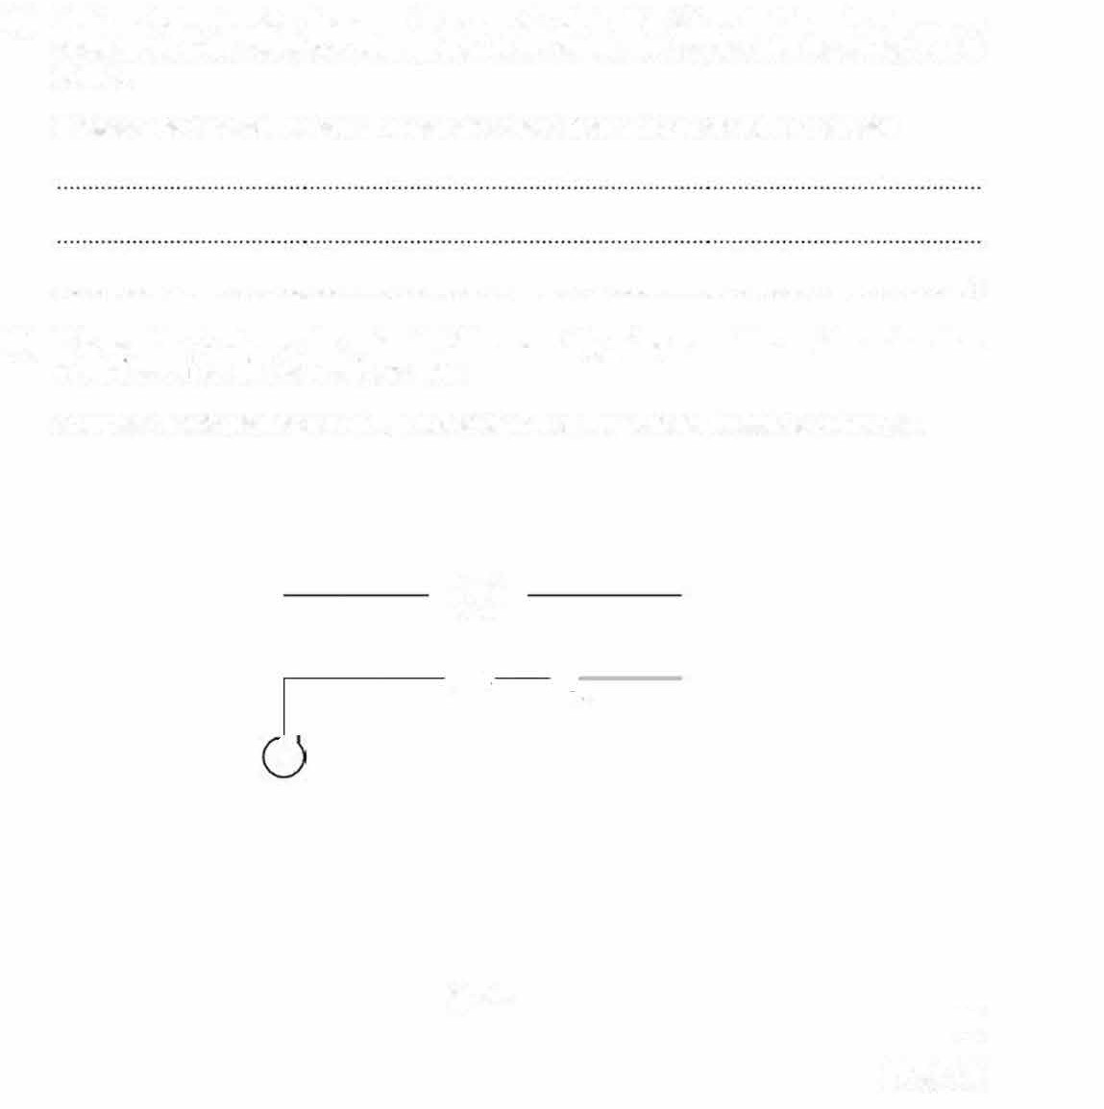
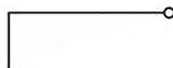
- (a) Another student decides to connect the crocodile clip in Fig. 3.1 so that there is only a very small length of the resistance wire included in the circuit. The teacher tells the student not to do this.
Suggest one practical reason why values of d less than 20.0cm should not be used.

. ...................·····...................................·····. (1]
(b) It is possible to change the potential difference V by using a variable resistor rather than using different lengths of resistance wire.
Complete the circuit diagram in Fig. 3.5 to show how the variable resistor is connected.

-0-

A

Fig. 3.5
[2]

(Total: 14]

- A student investigates the average speed of a trolley moving along a horizontal bench.
The trolley is placed on a ramp and released from rest. Some of the apparatus used is shown in Fig. 4.1.

set of masses
--stand

trolley

ramp bench

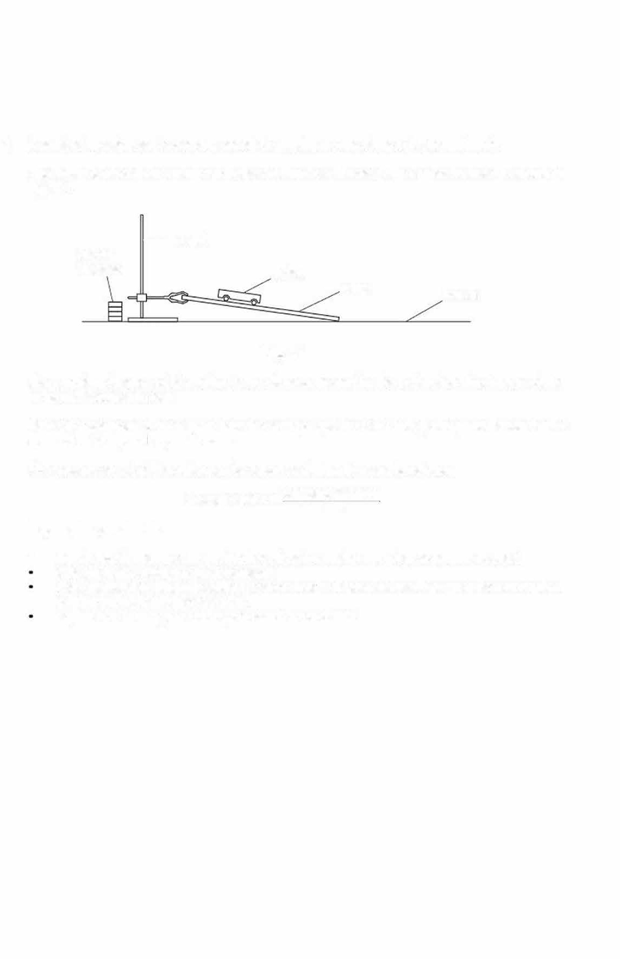

Fig. 4.1
The stopping distance of the trolley is the distance moved by the trolley from the bottom of the ramp until it comes to rest.
Plan an experiment to investigate how the average speed of the trolley along the bench until it comes to rest depends upon its mass.
The average speed of the trolley can be calculated using the equation shown.
average speed = stopping distance
time
In your plan you should:
- explain briefly how to carry out the investigation, stating any other apparatus needed state the key variables to keep constant
draw a table with column headings to show how to display the readings (you are not required
to enter any readings into the table)
explain how to use your readings to reach a conclusion.

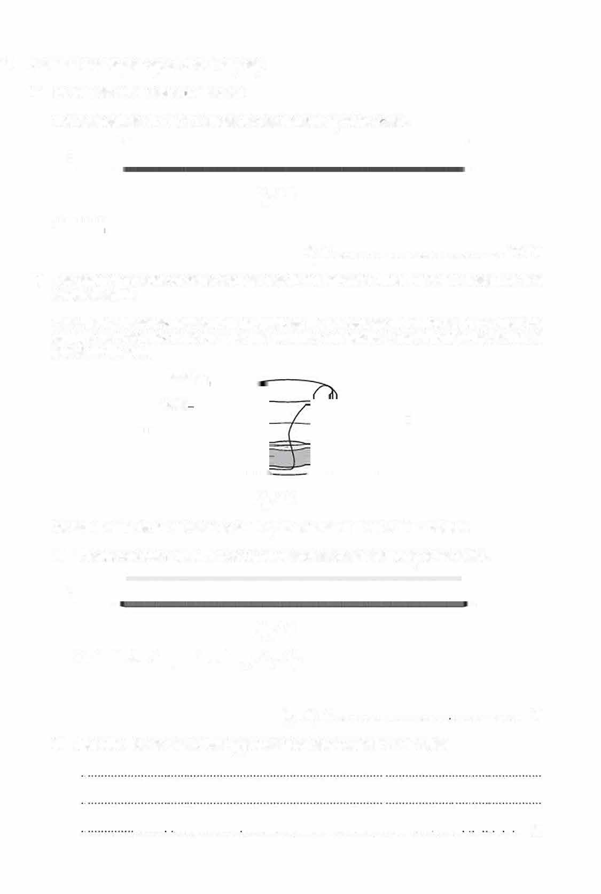
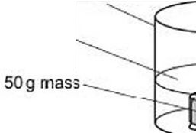
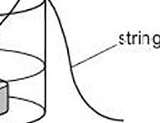
- A student investigates specific heat capacity.
  - He puts 2Gcm3 of wa:er in a beaker.

The thermometer in Fig. 1.1 shows the temperature 01 of the \Sater.

Fig. 1.1

0₁ = ................................................... ·c 111
  - The teacher has placed some 5Og masses in boiling water. Each mass has been tied to a length of string.

The student takes the beaker of water to where the masses aB in boiling water. He uses the string to remove one mass from the boiling water and places ii carefully into the beaker as shown in Fig. 1.2.
beaker, water

Fig. 1.2

He then returns to his workstation and replaces the thermometer in the beaker.
- The thermomete· in Fig. 1.3 shows the maximum temperature 02 of the water.

Fig. 1.3

Calculate the temperature change 02 - 01 .

82-81 = ··············· ······"··········· ····················· [1)
- Describe how to ensure that 82 is measured as accurately as possible.

......... . .................... ........................................................ ........ . .. [2)

15 (a)

- T he beaker is made from a special type of glass. Suggest why it is suitable for this experiment

. [1]
- Calculate the specific heal capacity cm of the 50g mass using the equation:


c 4.2(82-81 )
m = 2(100-82)

cm = ........................................... J/(g °C) [1]
  - (i) Describe two sources of error in the method used to determine cm.
- .... ..... ..................................... ............................... ......... ... ............................... ....... .........

- ···········································································--···························································

[2]
- Suggest two improvements lo the method.

  - ........................................................................................................................................

  - ........................................................................................................................................

[2)
[Total: 10)

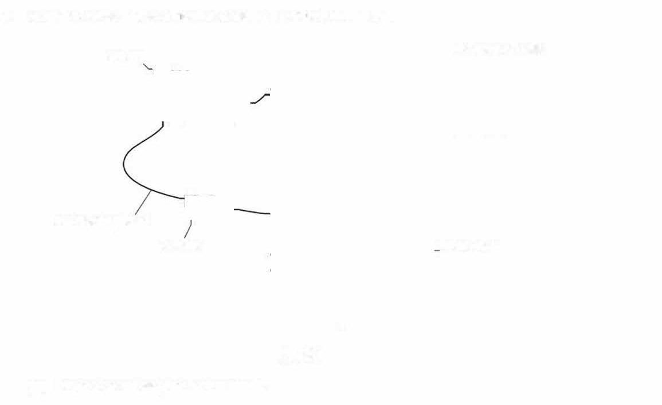
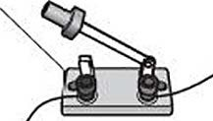
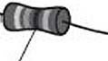
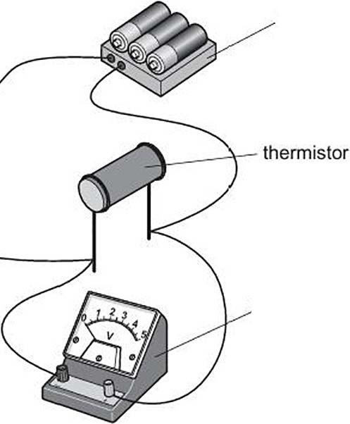
16 A student investigates a thermistor using the cir-cuit in Fig. 2.1.

switch
battery of cells
connecting lead
r esistor
voltmeter
Fig. 2.1
(a) Draw a circuit diagram of the circuit.

- The student measures the temperature of the room and records it.
The recorded result is shown in Fig. 2.2.

Room temperature Tw = 2o•c.

Fig. 2.2

Fig. 2.3 shows the reading Vw on the voltmeter when the switch is closed.

•

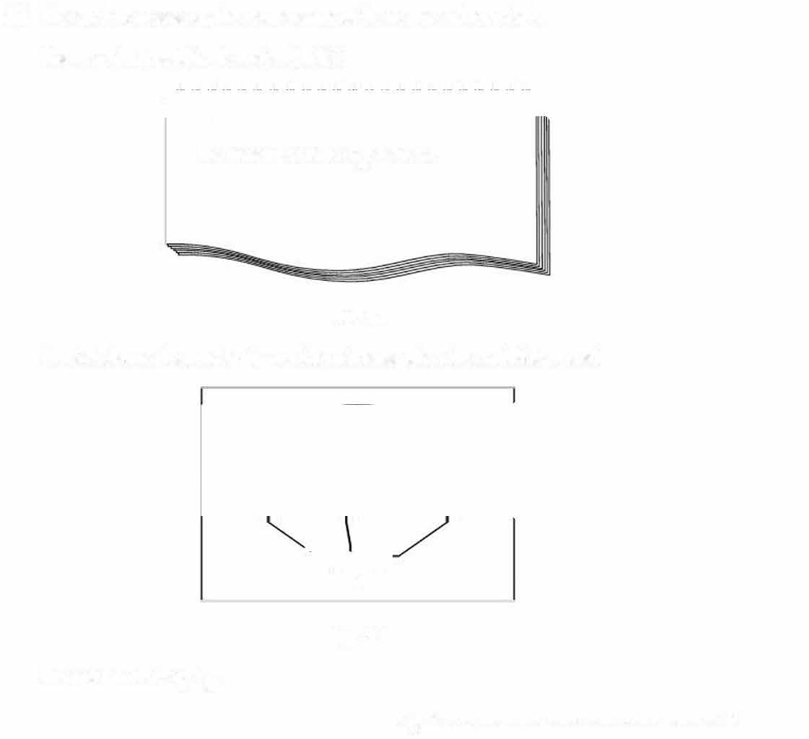
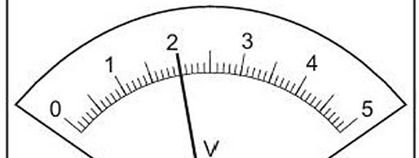
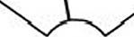

Record the reading Vw.
Fig. 2.3

Vw = ...................................................... V [1]

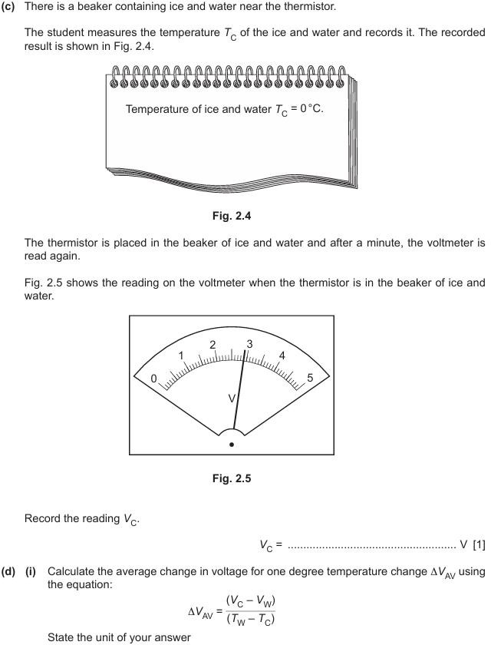

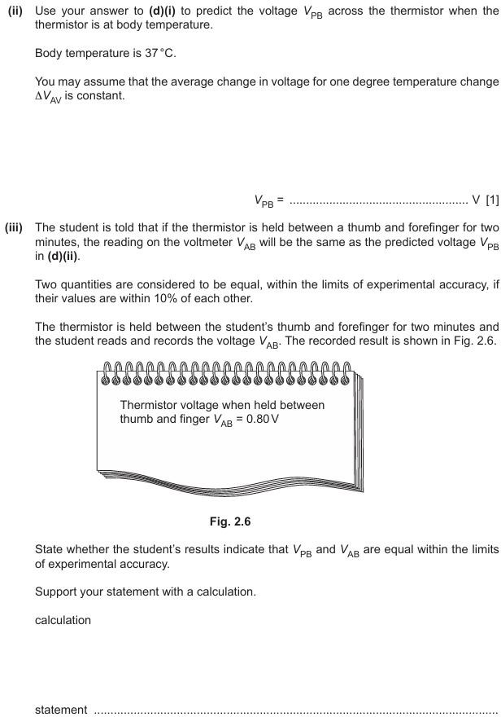

17 A student attaches a propeller to an electric motor driven by a O to 12 V d.c. power supply as shown in Fig. 4.1.

clamp stand
0 to 12 volt d.c. power supply

electronic balance

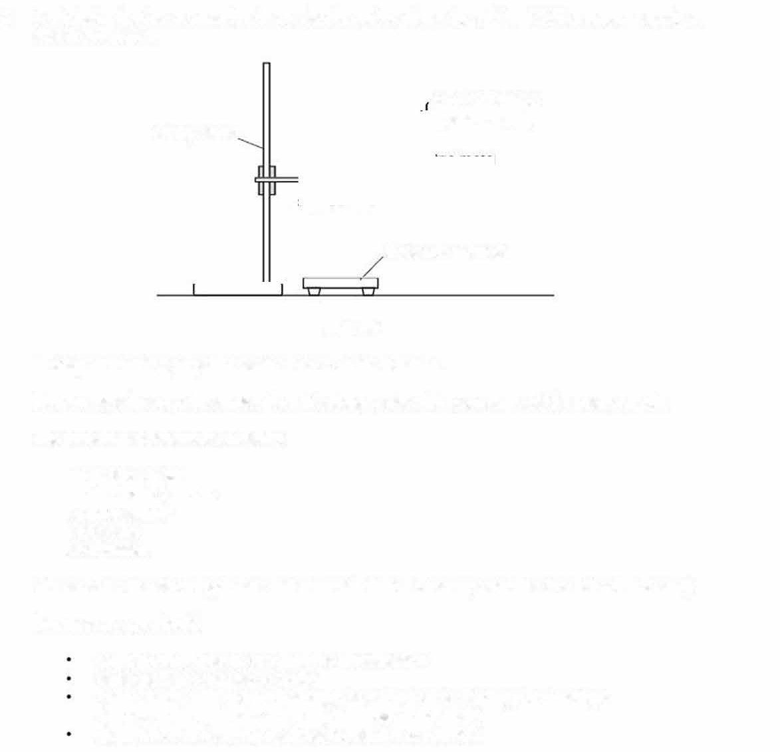
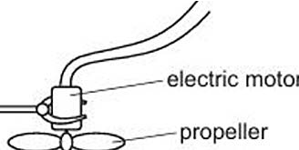

Fig. 4.1
Moving air from the propeller exerts a force on the balance.
Plan an experiment to investigate how this force varies with the voltage of the power supply. The following apparatus is available:
an electric motor
an electronic balance a power supply
a propeller a voltmeter.
You can also use other apparatus and materials that are usually available in a school laboratory. In your plan, you should:
explain briefly how to carry out the investigation
state the key variables to control
draw a table, with column headings, to show how to display your readings (you are not required to enter any readings in the table}
explain how to use your readings to reach a conclusion.

- A student measures the capadty of a drinks cup by three different methods. The capacity of a cup is the maximum volume of liquid that it can hold.
  - method 1
The student measures:
    - the height h of the cup
    - the diameter D of the top of the cup
    - the diameter d of the bottom of the cup.
Fig. 1.1 shows a full-size diagram of the cup.

D

'
>-,
rt' -- --

h

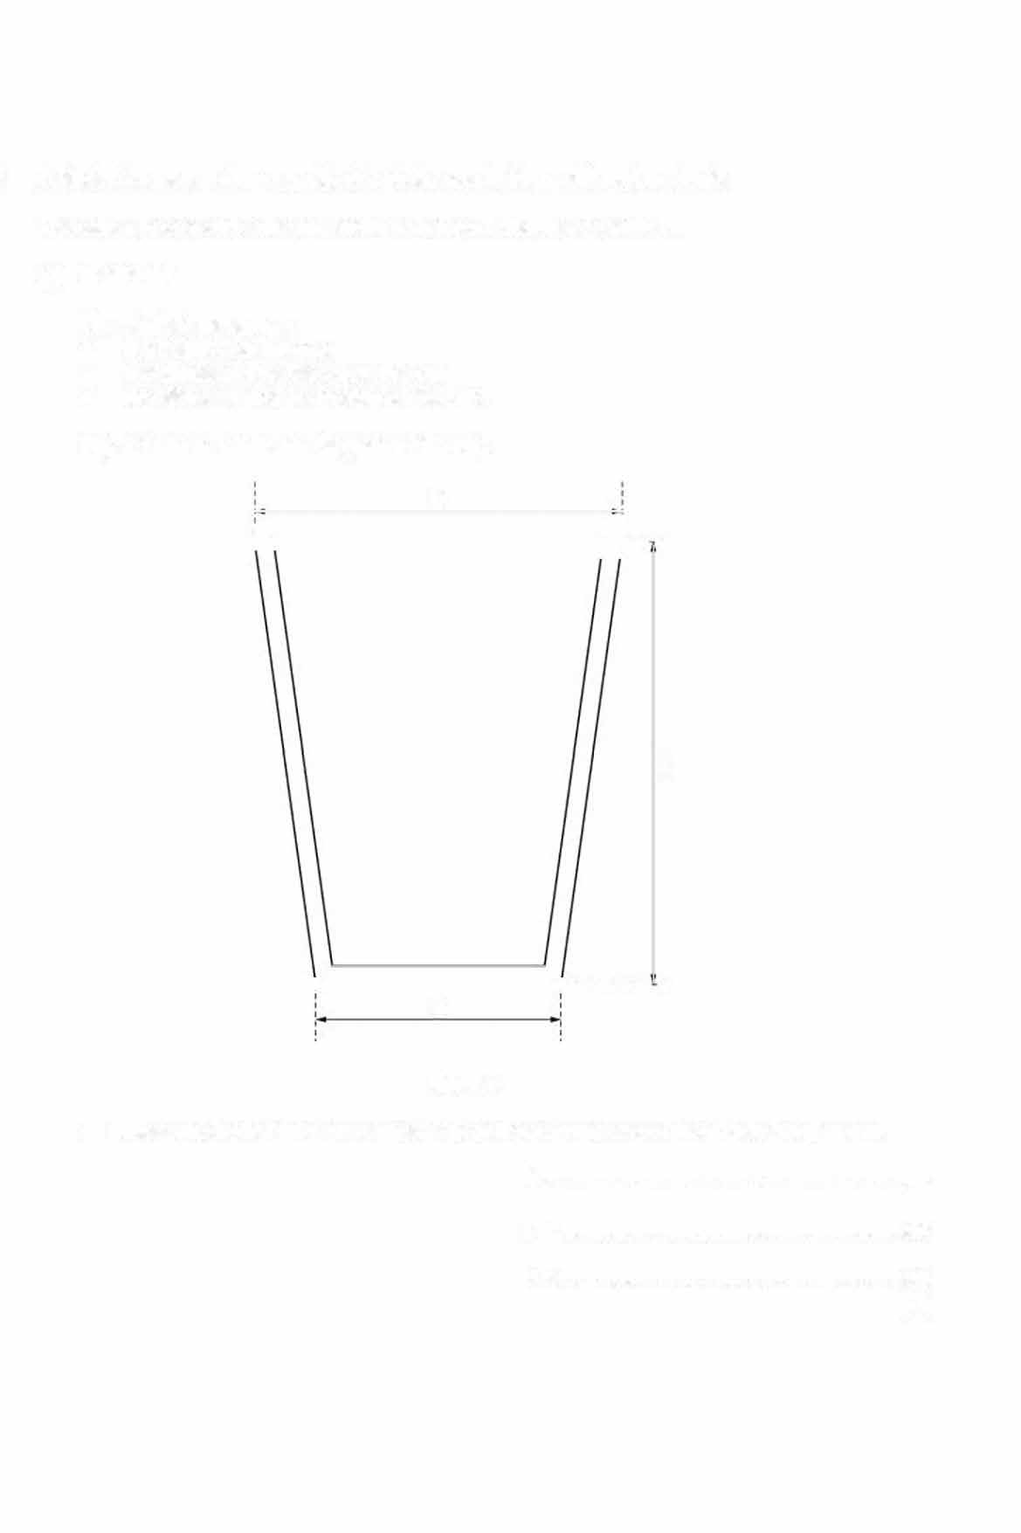

1----------+--------- -·
d

Fig. 1.1
- Measure the height h, the diameter D and the diameter d of the cup in the diagram.
h = cm
D = cm
d= cm
[2]

- Calculate the average diameter dA of the cup using your readings from (a)(i) and the equation:
_ (D + d)
d
A- 2

dA= cm[1]
{iii) Calculate a value for the capacity V1 of the cup using the equation:
V rrd/h
=
1 4

  - method 2
V1 = cm3[1]


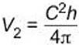
The student uses a lenqth of strinq and a metre rule to determine the averaqe circumference
C of the cup.
The student:
- wraps some of the string 5 times around the cup
- measures the length 1 of string used.
I= 87.9cm
- Calculate the average circumference C of the cup.

C = cm[1]

- Use your values of h from (a)(i) and C from (b)(i) to calculate a value for the capacity V2 of the cup using the equation:

V₂ = cm3[1]

- method 3

The student:
  - fills a measuring cylinder with water, up to the 220cm3 mark
  - pours water from the measuring cylinder into the cup until the cup is full
  - records the new reading R on the measuring cylinder.
Fig. 1.2 shows the new reading R.
cm3

40

-1---water
20

- Write down the new reading R.
Fig. 1.2

R= .................................. ............... cm3 (1]

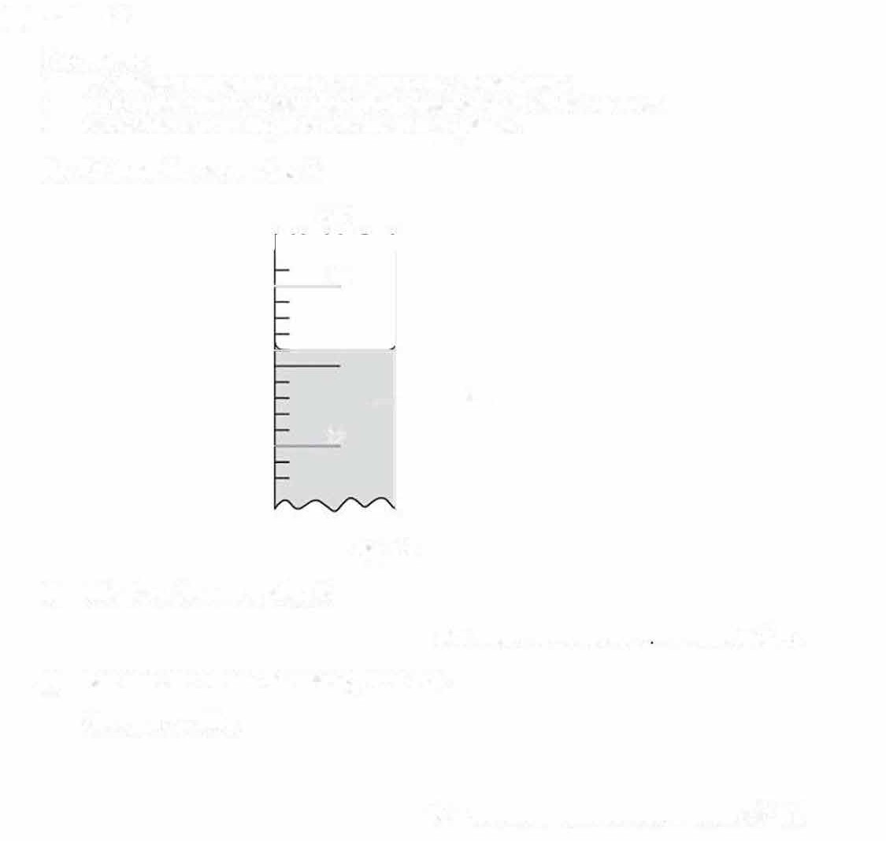
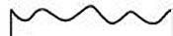
- Determine the volume of water V₃ in the cup. Show your working.

V₃ = .................................................. cm3 (1]

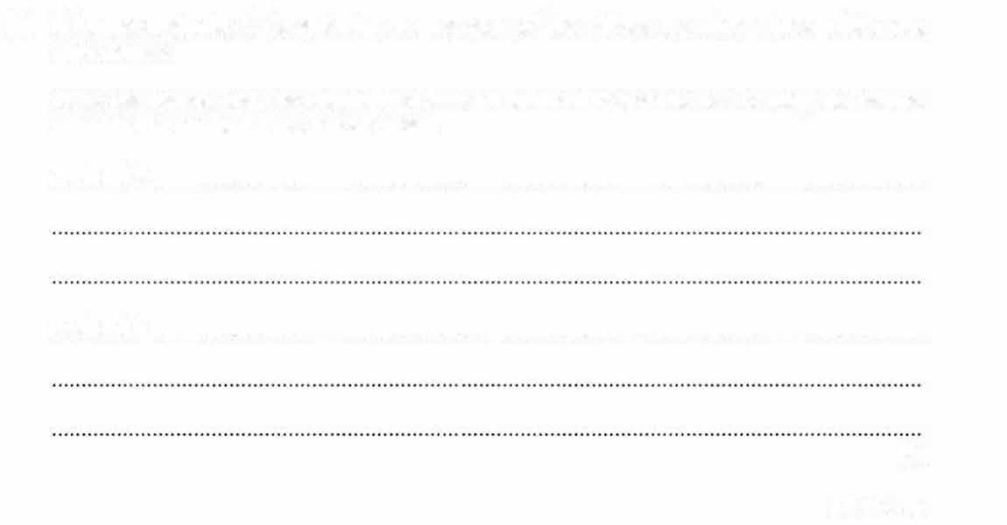
- All three methods of determining the capacity of the drinks cup give values which are approximate.

State one reason why the volume calculated in method 2 and one reason why the volume calculated in method 3 are not accurate.

method 2 ..................................................................................................................................

method 3 ..................................................................................................................................

[2)
[Total: 10)

- A student investigates the effective resistance of different combinations of resistors and lamps in circuits.

The student sets up the circuit shown in Fig. 2.1.
power supply

'- -1v1- -'

Fig. 2.1

  - The student:
closes the switch
measures the potential difference V₁ across the resistors and the current !₁ in the circuit opens the switch.

The readings on the voltmeter and ammeter are shown in Fig. 2.2 and Fig. 2.3.

0

Fig. 2.2

.5 0.6 0.7

A
3

0.8
0.9

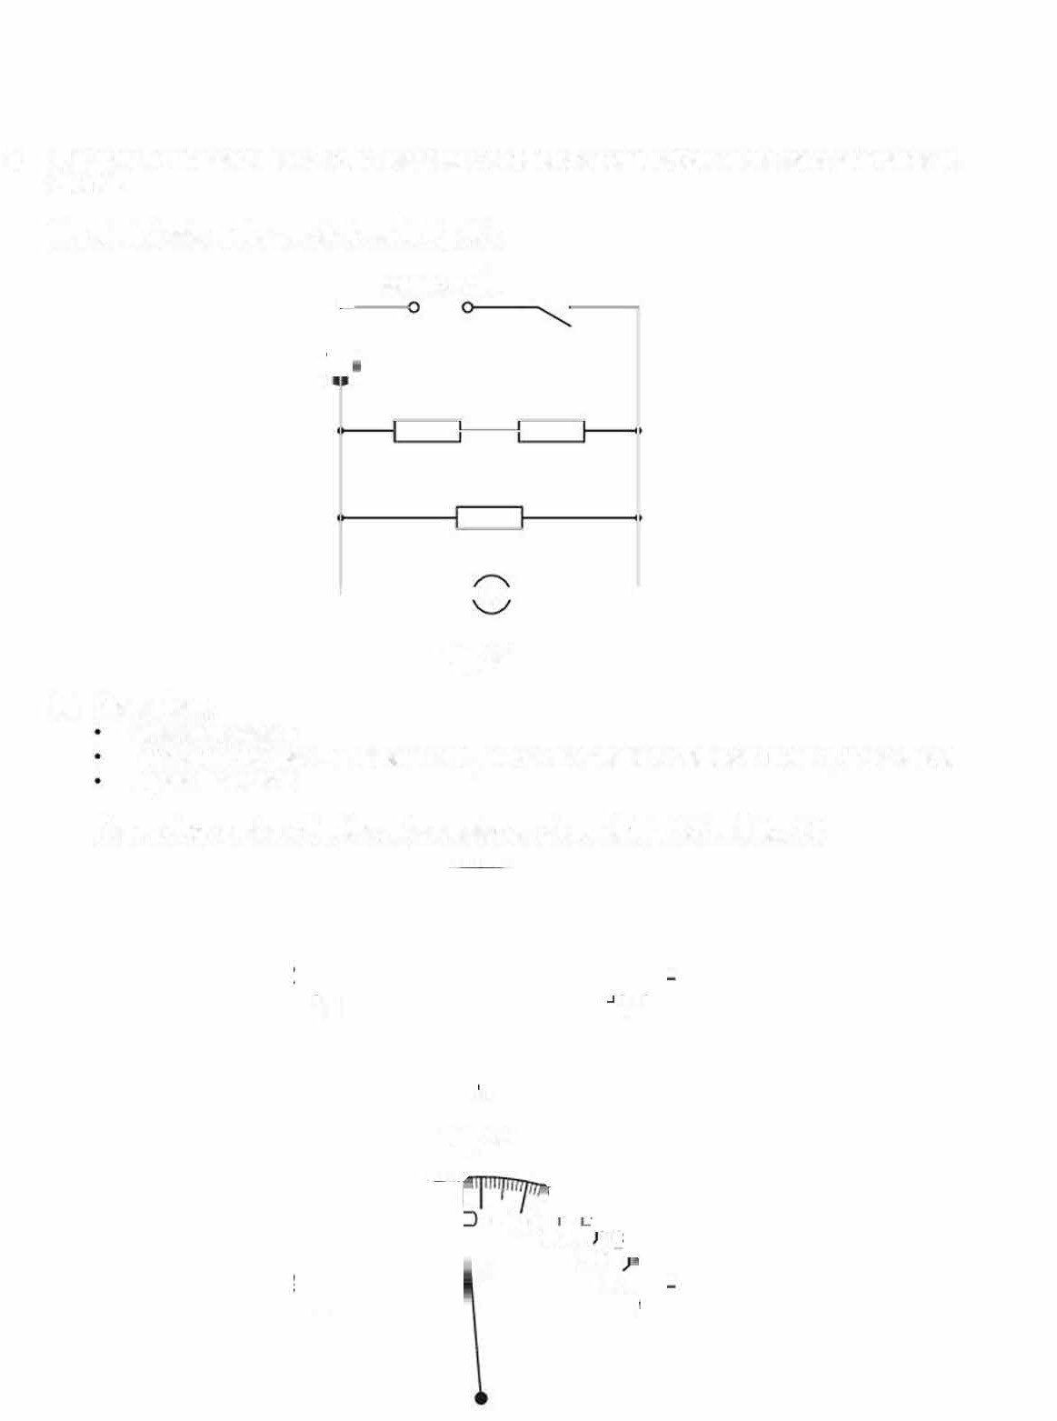
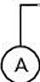
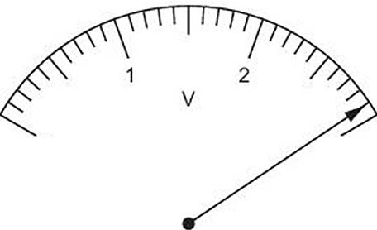
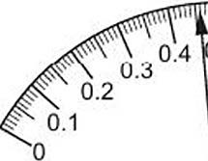
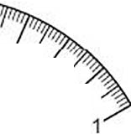

Fig. 2.3

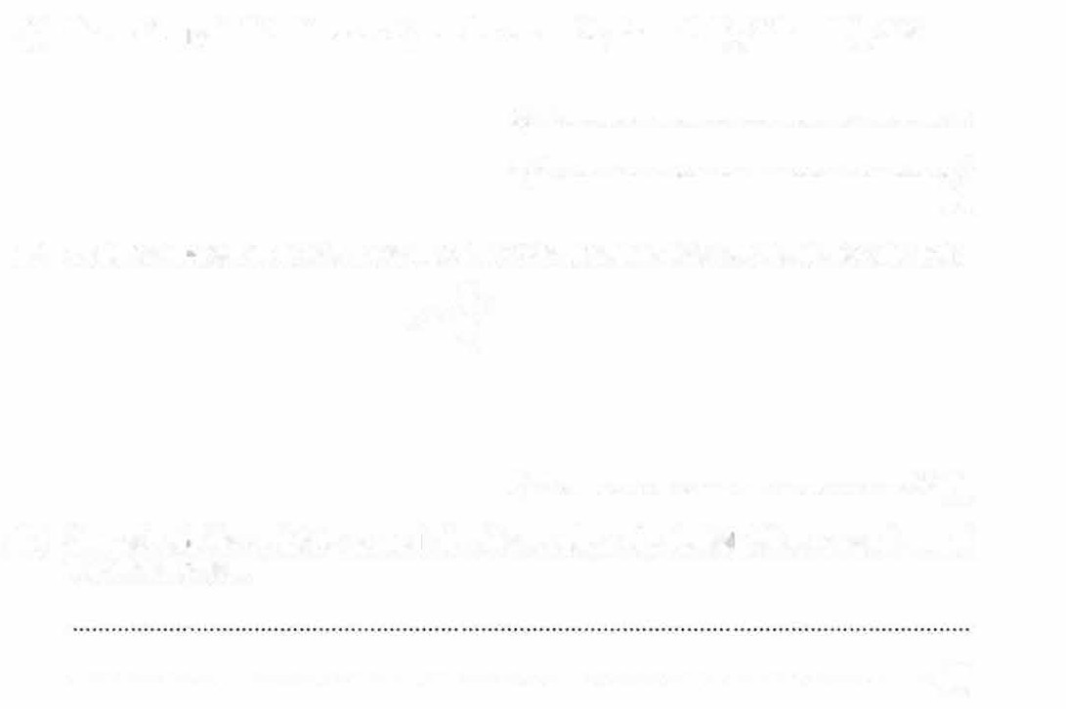
- Record the [Potential difference V1 and the current 11 shown in Fig. 2.2 and Fig. 2.3.
V₁ = V
1₁ = A
[2]
- Calculate the effective resistance R₁ of the combination of resistors using the equation:
V
R
1 =-11 1

R₁ = ..................................................... Q [1]
- Suggest why the switch is opened after the readings of potentia I difference and current have been taken.

. (1)

  - The student:
rearranges the circuit so that the resistors are connected as shown in Fig. 2.4 closes the switch
measures the potential difference V₂ and the current 1₂
opens the switch.
power supply

�------< V �

The new readings are:
Fig. 2.4

V2 = 2.8V
I₂ = 0.88A

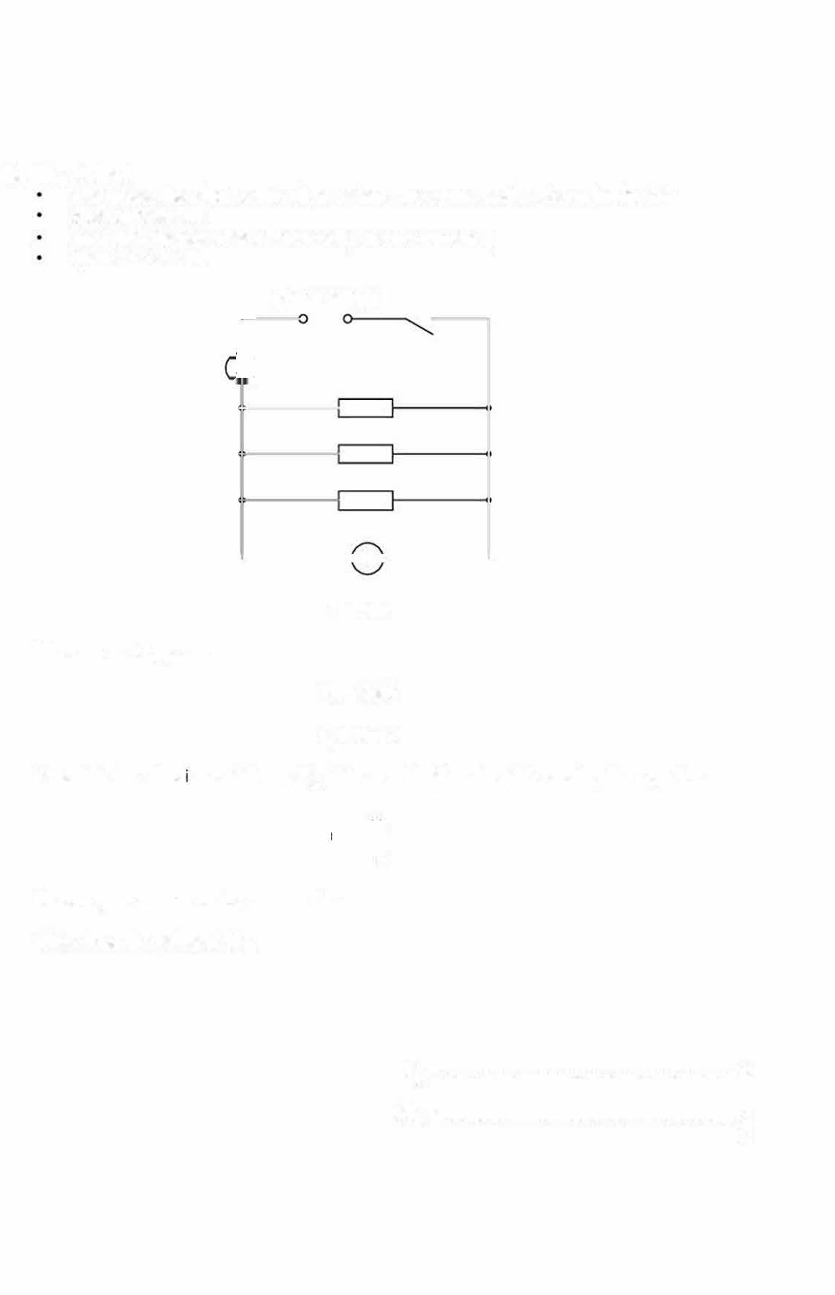
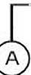
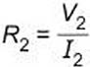
Calculate the effect ve resistance R₂ of the combination of resistors using the equation:

Record your answer on the answer line. Write down the value of 2R₂

R2 = Q
2R₂ = Q
11 J


If the resistors are identical, theory suggests that R1 = 2R2.
(c)
Two quantities can be considered to be equal within the limits of experimental accuracy if their values are within 10% of each other.

State whether the results indicate that the resistors are identical. Support your statement with a calculation.
calculation

statement .................................................................................................................................
...................................................................····· [2]

- The sludent repeats the experiments in (a) and (b) but replaces the resistors with lamps. He ottains the following results:
The effective resistance R₃ of the combination of lamps connected as in Fig. 2.1 is 5.2Q. The effective resistance R₄ of the combination of lamps connected as in Fig. 2.4 is 3.4Q.

The teacher explains that the resistance of the lamp filaments changes due to a heating effect and therefore R₃ is not eQual to 2R₄.
Suggest one observation that the student makes while doing the experiment that supports the teacher's explanation.

. I1 J

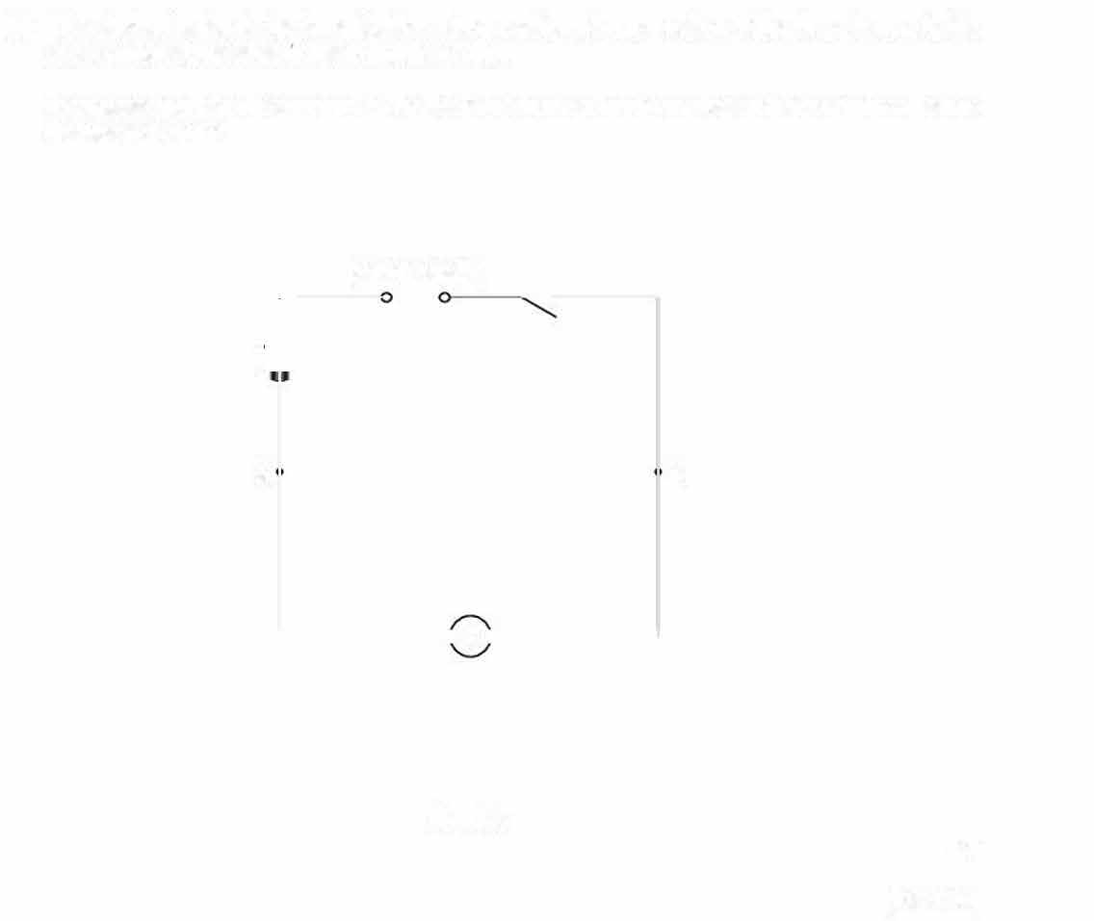
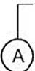
(e) The student extends the investigation using a different combination of the three lamps to the two combinations already used in (a) and (b).

Complete the circuit diagram in Fig. 2.5 to show a third way of connecting three lamps between X and Y.
power supply
X
y
'--------iV -'
Fig. 2.5
[Total: 10]
[2]


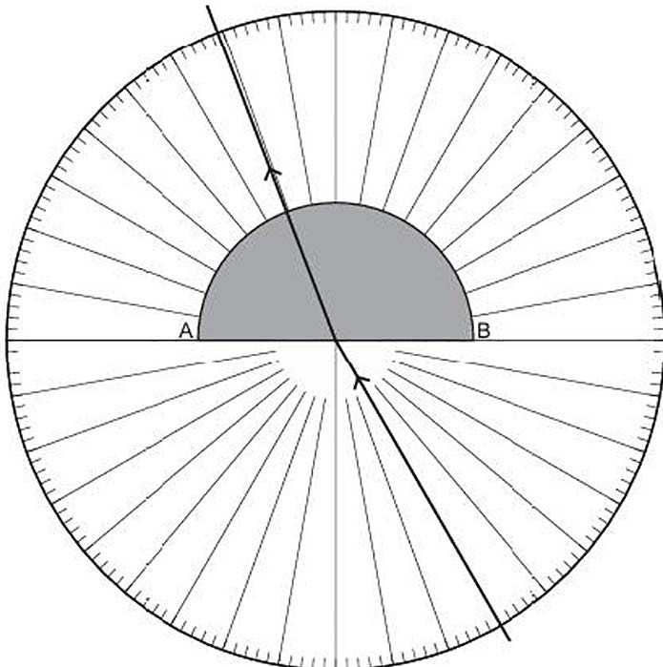
- A student measures the refractive index of oil.
Oil is poured into a semi-circular transparent plastic container as shown in Fig. 1.1. The container is placed on top of a 3so• protractor as shown in Fig. 1.2.
oil container

flat side

Fig. 1.1

fig. 1.2
(viewed from above)

  - The line AB shows the ,osition of the flat side of the plastic container.
A ray of light is incident at the midpoint of AB with an angle of incidence i = 30• as shown in Fig. 1.2.

�) State one property of the oil that is needed to ensure that the experiment worts.
. (1)
- On Fig. 1.2, measure the angle of refraction r of the light in the oil.
r= ............... ..................... ..... ...... ..... . • (1)

- The student repeats the procedure described in (a) and measures the angle of refraction r for angles of incidence i= 1s•, 45•, 60•, and 75•_ The results are shown in Table 1.1.
Table 1.1

  - Complete Table 1.1 with your value of r from (a)(ii).
On the grid provided in Fig. 1.3, plot a graph of r on the y-axis against ion the x-axis. Start your axes from (0,0). Draw a smooth curve of best fit.

0

Fig. 1.3

  - Describe the relationship between iand r shown by the graph.

  - Use your graph to find the value of r when ; = so•. Show on the graph how you determine your answer.

(4]

11J


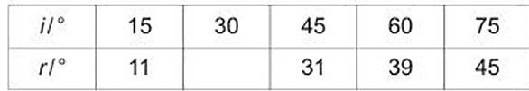

r = ....................................................... • [2]

  - Theory suggests that the refractive index n of the oil is given by:
n=-si-n. i

sin r
Using i and your value of r from (b)(iii), calculate a value for n. Give your answer to an appropriate number of significant figures.

n = (2]
  - On Fig. 1.4, sketch the graph when sin r is plotted against sini. No calculations are required.

sin r

0+-
sin i

Fig. 1.4

11J

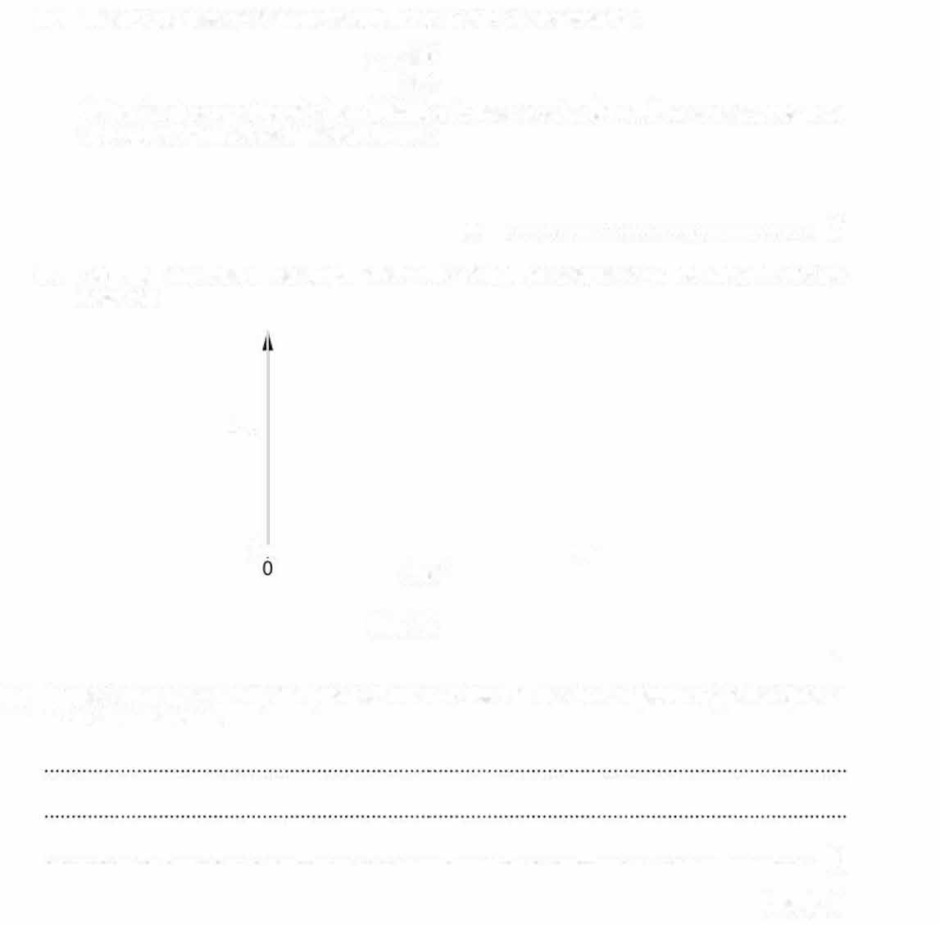
- Suggest one reason why the practical method used in this investigation might not give an accurate value for n.

. [1]

[Total: 13]


- A student investigates the current in a resistor of fixed resistance.
The following apparatus is available:
- ammeter
- electrical connecting leads
- a resistor of fixed resistance
lamp switch

variable resistor
•
6V battery LED
•
•
voltmeter.
  - State which piece of apparatus is used to measure current.
. [1]
  - (i) The student measures the current I fo r a range of potential differences.
Draw a circuit diagram to show the circuit the student uses. You may us.e some or all of the apparatus available.

[3]
(ii) Describe how the student obtains different values of the potential difference across the fixed resistor.

. I1 J

- A student determines the acceleration of free-fall by timing the oscillations of a pendulum. The pendulum s shown in Fig. 2.1.

==C)===r-'-i-clamp

I
stand

bob

Fig. 2.1
  - On Fig. 2.1, measure the length I of the pendulum in centimetres to the nearest milimetre.
I= .................................. cm (1)
  - Fig. 2.1 is drawn one•eighth actual size. Length L is the actual length of the pendulum. Calcu ate L.

L= ............................... .... cm (1)
  - The student gives the bob a small displacement and releases it so that it sNings bacl:.wards anc fcrwards. Fig. 2.2 shows one complete oscillation of the pendulum.
r-"-�-clamp
',"''
' '
''' '''
'''' ''''
'' '
'''/ \'''

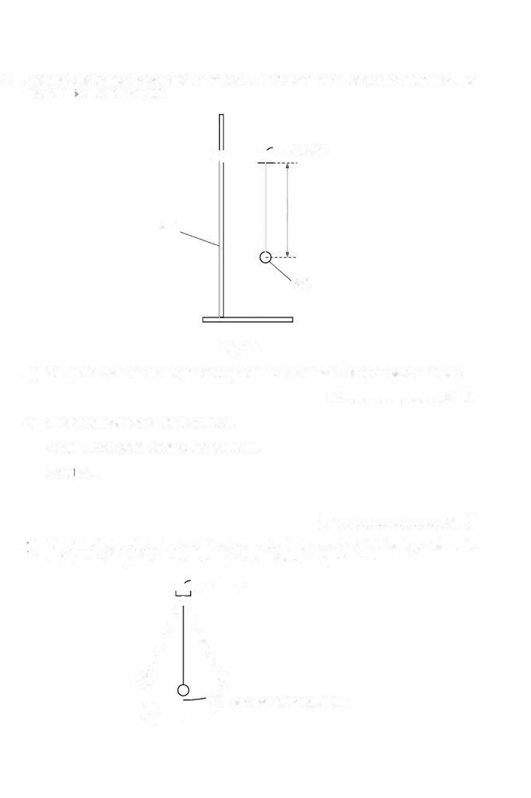
0
.....__
..,.O

one complete oscillation

The student measures the time I for 20 complete oscillations. The time I is shown on the stop-watch in Fig. 2.3.

- Write down the time /.
Fig. 2.3

l= s(1]


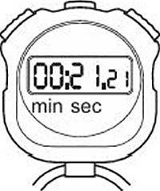
- The student measures the time / for 20 oscillations twice more. These times are shown.

21.30s 21.28s

Find the average time IAv for 20 oscillations of the pendulum.

IAV = S(1]

- The period Tis the time for one complete oscillation of the pendulum. Calculate T.

T= s(1]
- Calculate a value for g, the acceleration of free-fall. Use the equation shown.
11.1
g =
r2
Give your answer to 3 significant figures.

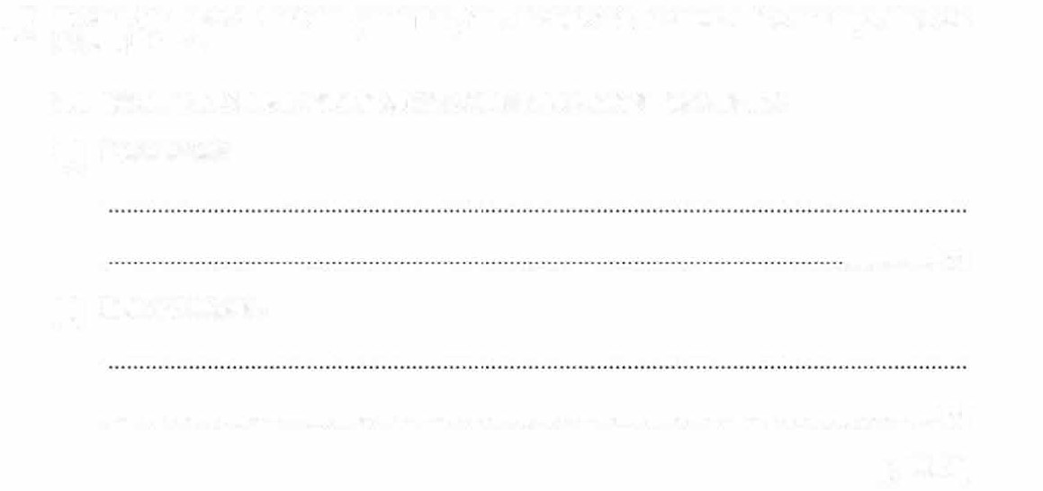
- To find the period T of the pendulum, the student first measures the average time for 20 oscillations.
Suggest why the student did not choose to measure the average time for:
  - 2 oscillations
. I
(ii) 200 oscillations.
. I
[Total: 9)

- A student uses a ray box to investigate the refraction of a ray of red light as it passes through a semi-circular glass block.

He sets up the apparatus on a sheet of paper as shown in Fig. 3.1.

sheet of paper
--+--�

ray box

red filter

normal
�

semicircular glass block

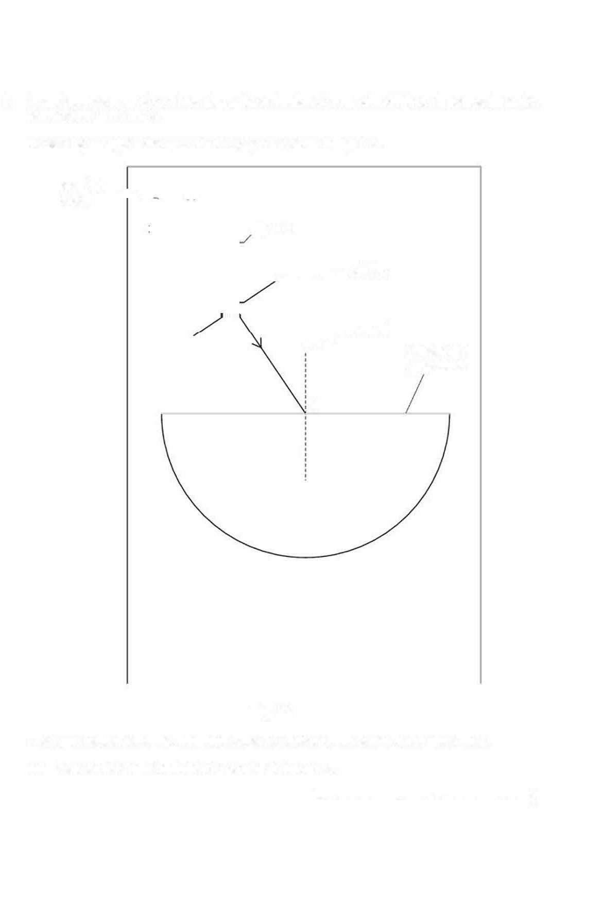
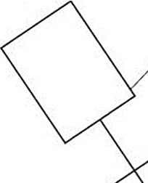
M

Fig. 3.1

The ray is incident at M, the mid-point at the flat surface of the semi-circular glass block.
  - Measure the angle of incidence i of the ray at point M.
; = 11 J

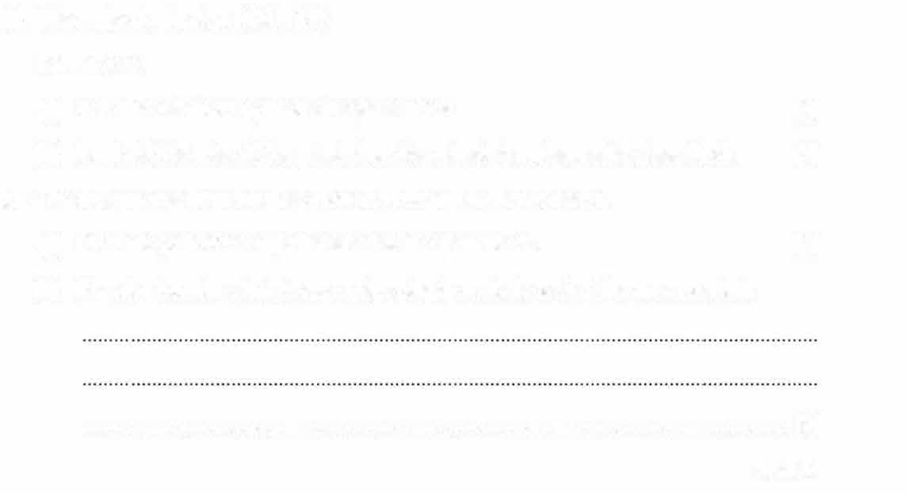
  - The angle of refraction at Mis 22•. On Fig. 3.1:
- draw the refracted ray inside the glass block (1)
- label with the letter N, the point where the refracted ray leaves the glass block. (1)
  - The ray emerges from the glass block at N without further deviation.
- Draw the path of the ray after it leaves the glass block. (1)
- Describe how the student uses optics pins to mark the path of the ray accurately.

......... ................·······. I
(Total: 5)

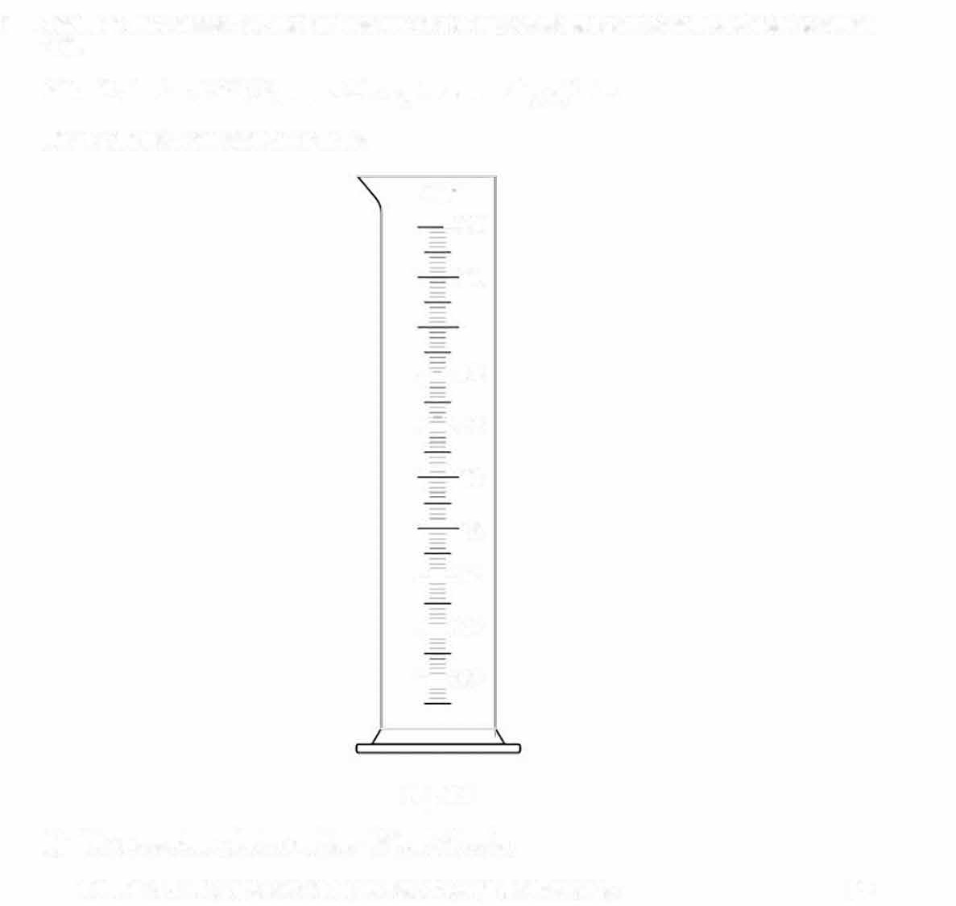
- A student investigates how the temperature of a volume of water changes as hotter water is added to it.

160cm3 of water at 2o•c is poured into a glass measuring cylinder. Fig. 1. 1 shows the measuring cylinder.
cm³
-250

225

200

-=-11s
-=-,so

- 125

- 100

-=-75

--=--25
--=--50

Fig.1.1
  - The measuring cylinder contains 160cm3 of water.
On Fig. 1. 1. draw the level of the water, showing the meniscus. [2]

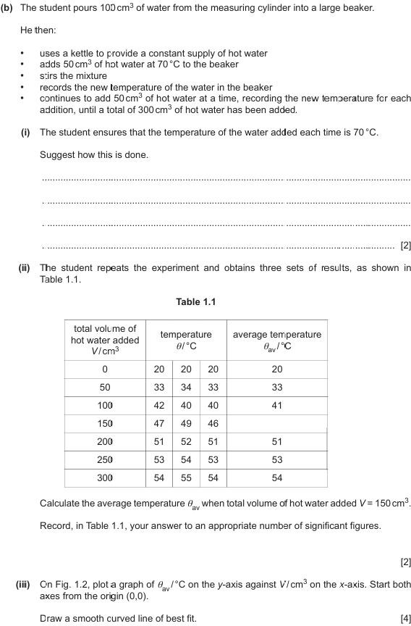

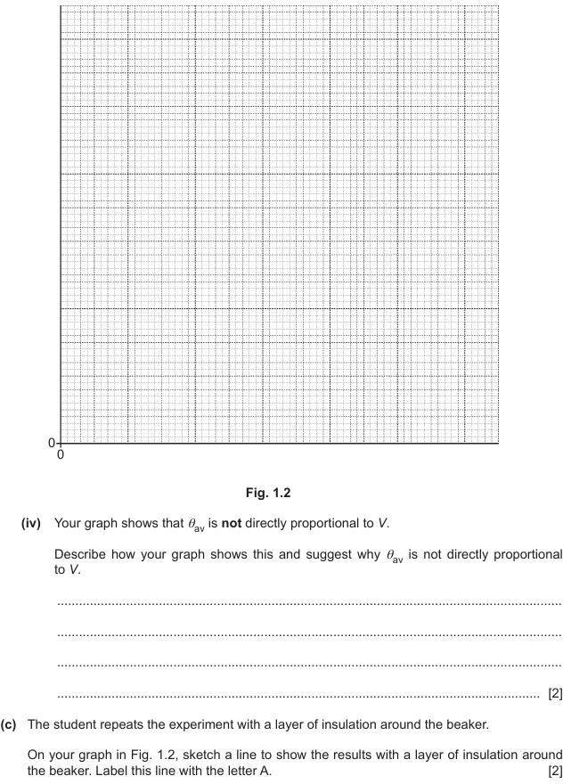

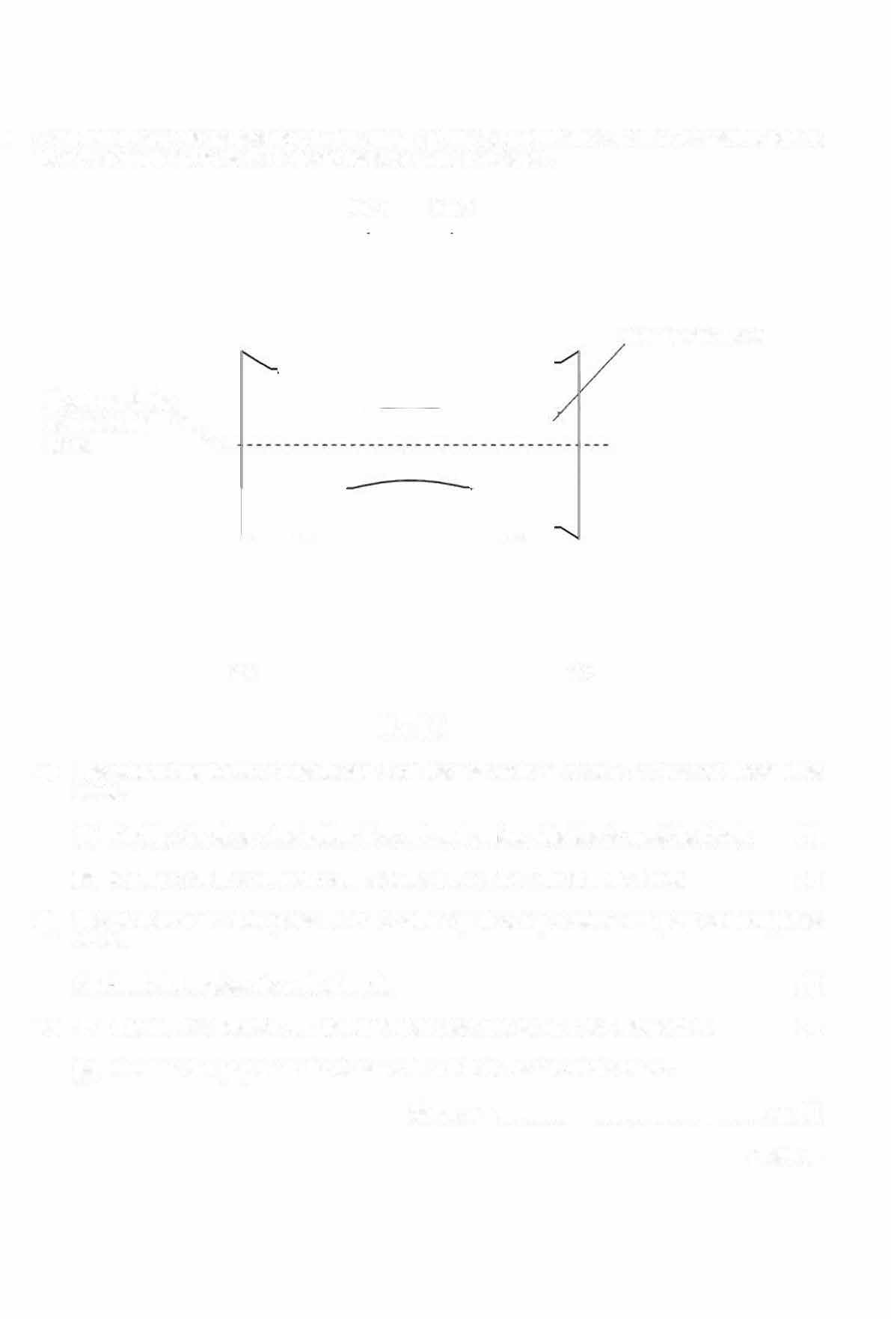
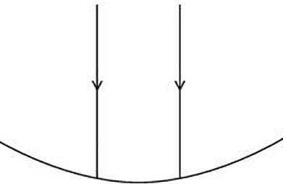
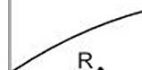
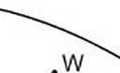
- A student directs two parallel rays of light, ray 1 and ray 2, towards the side of a transparent plastic block, as shown in Fig. 3.1. The block rests on a sheet of paper.

ray 1 ray 2

transparent block

line through the centre of the "---.
block .....______

s· ·x

Fig. 3.1

  - The student marks two points R and Son the path of ray 1 after it has passed through the block.

- On Fig. 3.1, draw a line joining Sand Rand continue the line to meet the block.
(1]

- On Fig. 3.1, draw a line to complete the path of ray 1 through the block. (1]

  - The student marks two points Wand X on the path of ray 2 after it has passed through the block.
On Fig. 3.1, complete the path of ray 2. (1]
  - (i) Extend lines SR and XWback until they meet at a point. Label this point F. (1]
(ii) Measure the perpendicular distance from F to the centre of the block.

distance = ................................................... cm (1]
[Total: 5]


- A student determines the diameter of a thin wire.
The apparatus available is:
- 2.0 m length of thin wire
- wire cutters
- ruler

  - Suggest how the student determines an accurate value for the diameter of the wire using
only the apparatus listed.

Draw a diagram to illustrate your method.

  - A second student determines the diameter using a different piece of apparatus. His value for the diameter is more accurate.

State the name of the different piece of apparatus he uses.

. 11 l
[Total: 4]

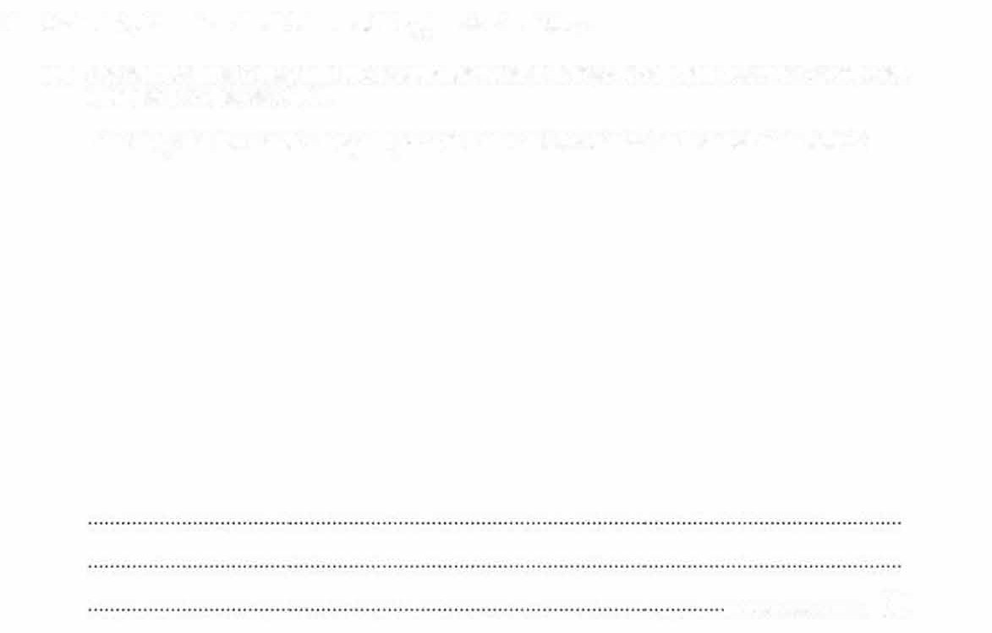
27 A student determines the thickness of the glass in a test-tube.

- The student uses a ruler and two rectangular wooden blocks to help him measure the external diameter D of the test-tube.
Describe, with the aid of a diagram, how the student determines an accurate value for D.
.. . . . ······•·•••••··· I

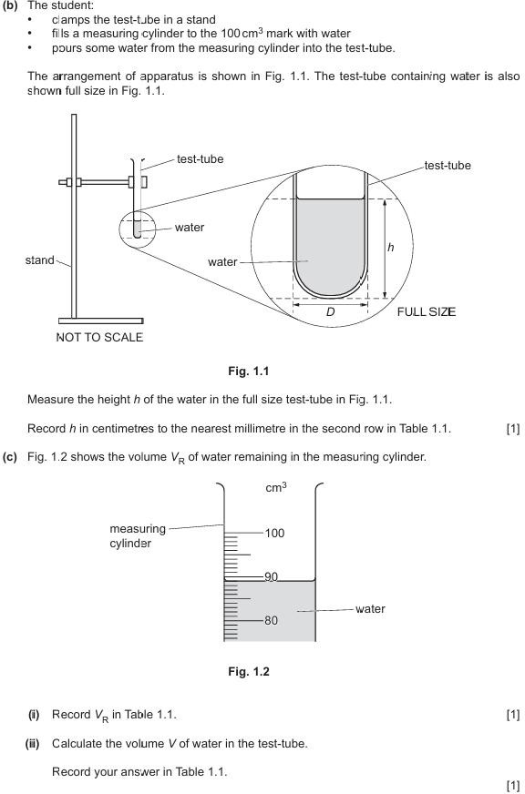

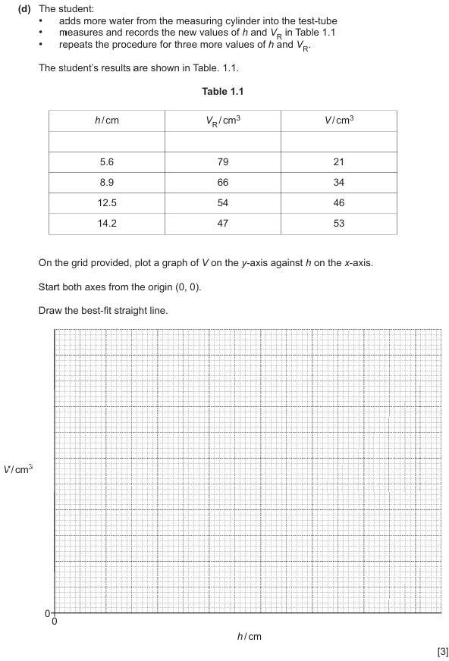


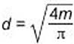
- (i) Calculate the gradient m of your line. Show all working and indicate on :he graph the values you use.

m= [21
(ii) If the test-tube is a perfect cylinder, then the internal diameter dis given by the equation:

Use your value at m from (e)(i) and the equation to calculate d.

d= cm[1)
- Your value for dis approximate.
  - State one difficulty in measuring the height h of the water in the test-tube and suggest how this difficulty can be overcome.

diffic1lty ............................................................................................................................ .

suggestion

[2)
(ij) Suggest another reason why your calcUlated value for dis only approximale.

. 11


(g) (i) Measure the external diameter D of the full size test-tube in Fig. 1.1.

Record Din centimetres to the nearest millimetre.
D = .......... .. .. ........ ···-······ ....... . cm [1)

(ii) Use your answers for (e)(ii) and (g)(i) to calculate tile thickness of the glass in the test-tube.
thickness of the glass= ........ ........................................... cm [1)

(To:al: 15)

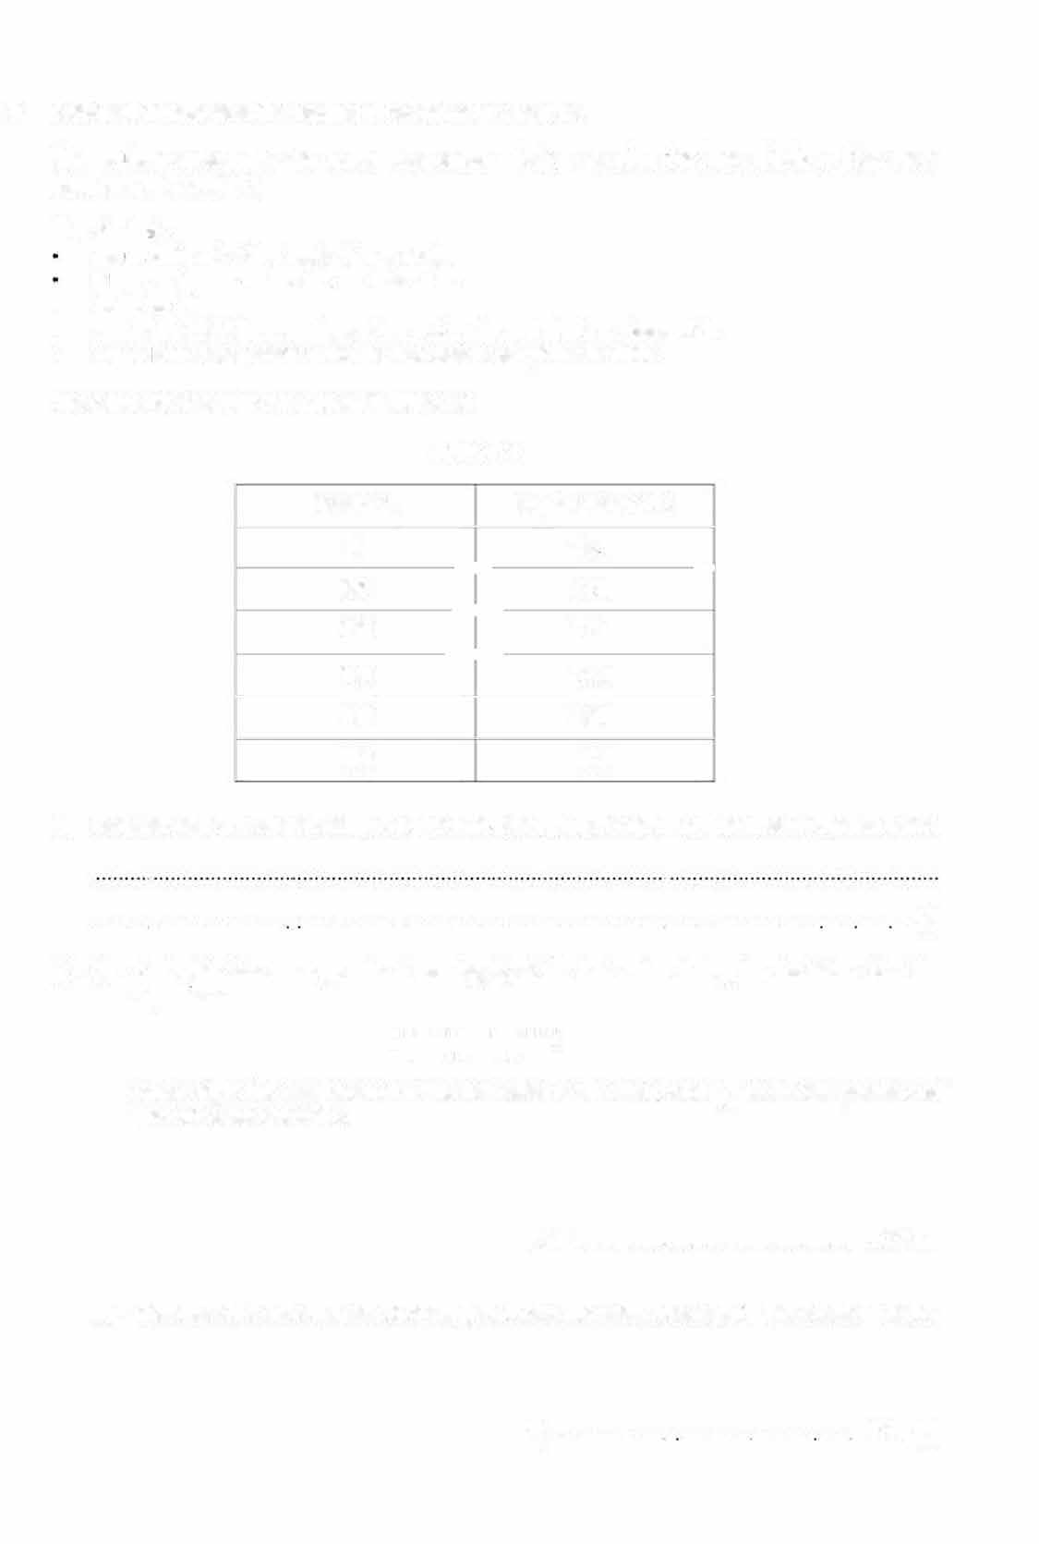
28 A student investigates the cooling of hot water in a beaker.
The student measures the room temperature before starting the investigation. The room temperature is 24.0'C.
The student:
�•OU rs 150cm3 of hot water into a beaker
�•laces a thermometer into the hot water
- waits for 30s
- reads the initial temperature of the hot water and starts a stop-watch
- records the temperature IJ of the hot water every 60s for 300s.
The student's readings are shown in Table 2.1.

Table 2.1

time 1/s |  | temperature | 01•c
0 | -- | 1\9 S | -
60 | -- | 83. 0
120 | -- | 77.5
180 |  | 73. 0
240 |  | 69.0
300 |  | 66.0

- Suggest why the student waits for 30s befo•e reading the initial temperature of the hot water.

••••••••• ·······················-······························································· ·························· ····- ····· ·· (1]

- f,) Calculate the average rate of cooling /'?1 of the hot water during the first 60s. Use the e�uation:

where 0₀ is the temperature of the hot water at the start, and 0₆₀ is the temperature of the hot water after 60s.

R₁ = ............................................... °C/s [1)

  - Calculate the average rate of cooling Ri of the hot water between I= 240s and I= 300s.

R = ............... · ············ -········· ······ 'C/s (1)
2

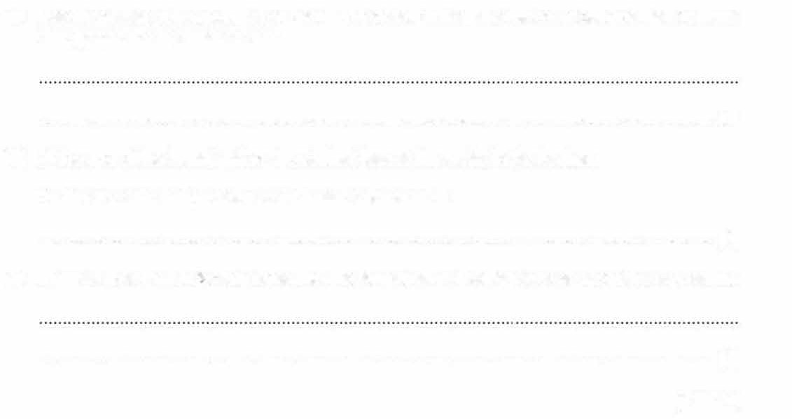
- Use the values you calculated in part (b) to describe how the rate of cooling of the hot water changes as the hot water cools.

. [1 J
- At the end of the investigation, the student leaves the water in the beaker. Predict the final temperature of the water 2 hours later.
. [1]
- Suggest how the student ensures that the temperature readings are as accurate as possible.

. [1]
[Total: 6]

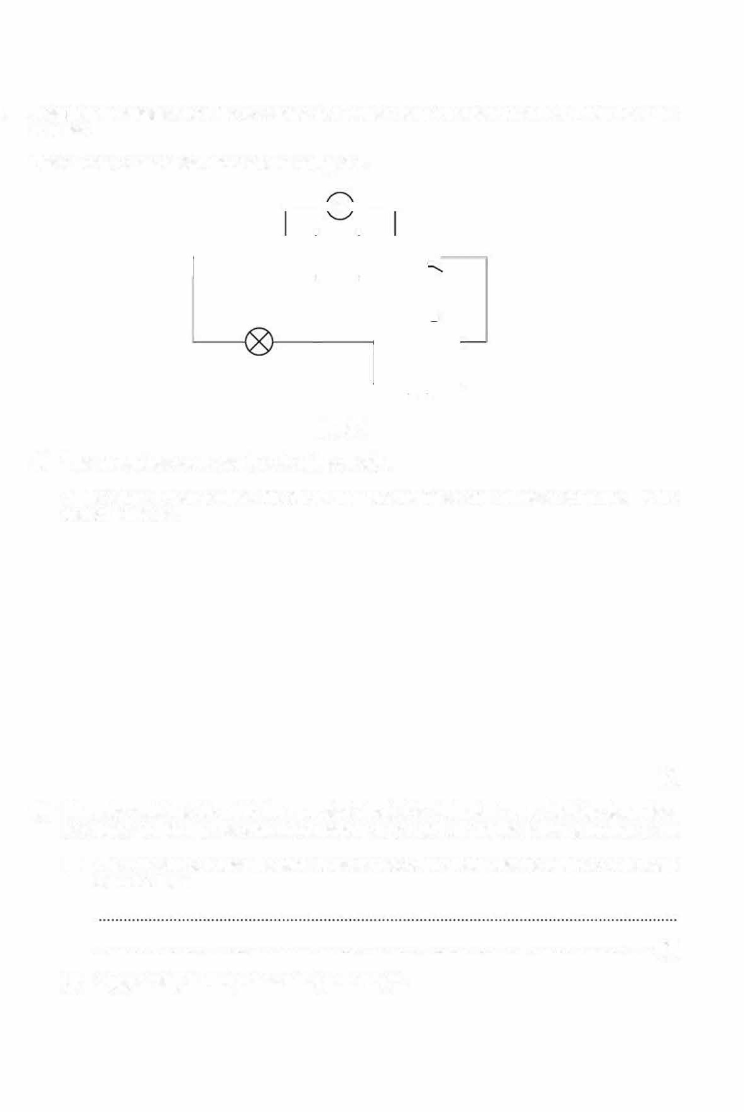
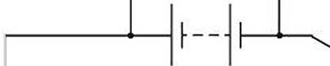
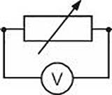
29 A student investigates how the resistance of a filament lamp changes when the current through it is varied.
The student connects the circuit shown in Fig. 4.1 .

.---!A --,

Fig. 4.1
- The student has connected the circuit incorrectly.
In the space below re-draw the circuit with the voltmeter and ammeter connected in the correct positions.

[2]
- When the switch is closed in the corrected circuit, the student observes that the lamp does not appear to light up. The filament of the lamp is not broken, and the battery is not run down.

  - What observation does the student make to confirm quickly that the filament of the lamp is not broken?

. I1J
  - Suggest why the lamp does not appear to light.

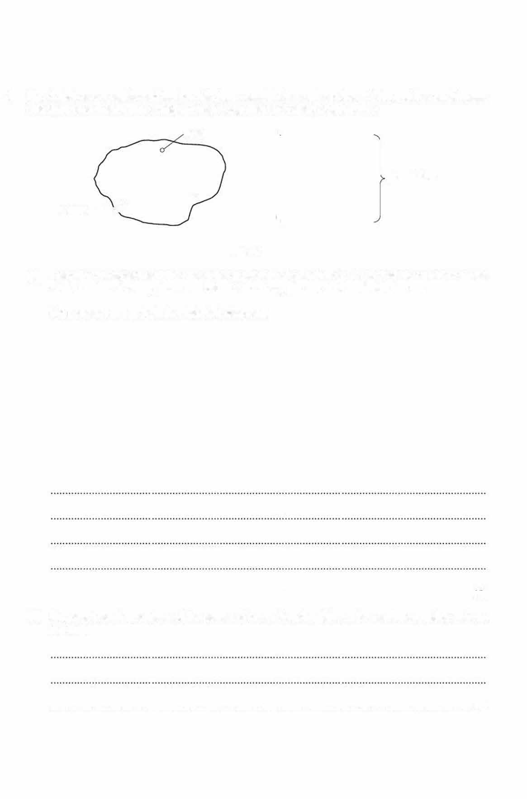
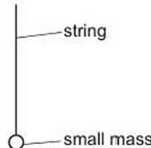
30 Fig. 4.1 shows a cardboard lamina with three small holes and a piece of string with a small mass attached at one end. The string and mass together are called a plumb line.
hole

plumb line
0
lamina---..⁰

Fig. 4.1

- Describe an experiment that uses the apparatus shown in Fig. 4.1 to find the centre of mass of the lamina. A clamp, boss and stand and a long pin are also available for use.
Your answer must include a labelled diagram.

- Suggest how the position of the centre of mass found in (a) can be confirmed using a sharp pin only.

.................................................................................................. ·········--········ ··· ·············-- [1]


31 A student uses pins to locate the image of an object formed by a plane mirror.
The student:

places an object pin P in front of the mirror
- looks into the mirror and sees an image of P
- places t.wo more pins W and X in front of the mirror and adjusts their positions so that the
image of P and pins W and X are exactly in line, one behind the other.
The position of the pins is shown in Fig. 3.1.

' ' '' '' ''' '' '' '' '' '' ''' '' mirror
•W

p. •X

�eye

Fig. 3.1

Without moving the object pin P, the student views the image of P from a different position and repeats the procedure with two more pins, Y and Z.
The position of all the pins is shown in Fig. 3.2.

\ \\ \ \ \ \ \\ \ \ \ \ \\ \ \ \ \ \\ \ \ \ mirror
•W .Y

p. •X

Fig. 3.2

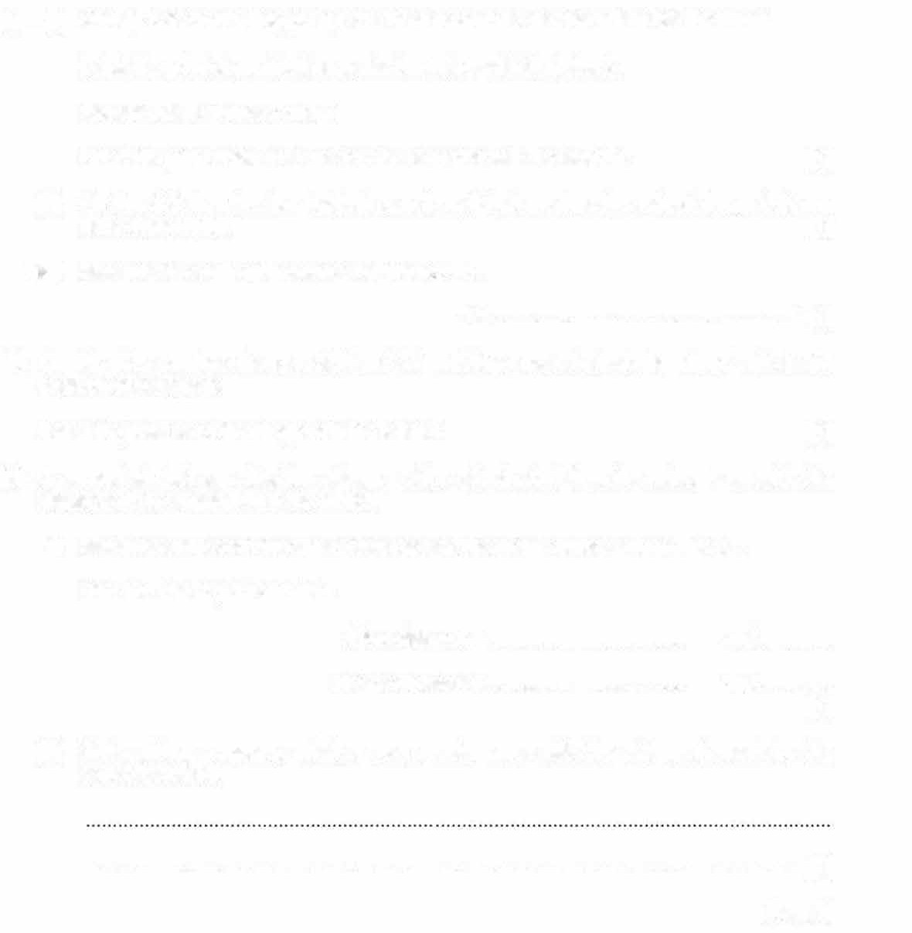
- (i) On Fig. 3.2, draw a line joining X to Wand continue the line until it hits the mirror.

Label the point where the line meets the mirror with the letter A. Repeat this for points Z and Y.
Label the point where this line meets the mirror with the letter B. (1)
(ii) On Fig. 3.2 draw the two incident rays from P that produce the reflected rays that you have drawn in (I). (1 J
(,iii) Measure the angle of incidence i of the ray PA.
i = ·······················································-° (1 J
- On Fig. 3.2, continue the rays XW and ZY until they meet behind the mirror. This is the position of the image.

Label the position of the image with the letter I. (1)
- A second student says that the distance of the object pin P from the mirror is equal to the distance of the image I from the mirror.

  - Measure and record the object distance and the image distance from Fig. 3.2.

Give the unit of your answers.

object distance = ................................... . unit .............

image distance = .................................... unit .............
(1)
  - State, giving a reason, whether your results agree with the statement made by the second student.

. (1 J

[Total: 6)


32 A student connects three identical lamps P, Q and R to a cell and a switch to make a circuit.
Lamp P is connected in series with lamp R, the switch and the cell. Lamp Q is connected in parallel with both lamps P and R.
{a)
Draw the circuit diagram.
[1]

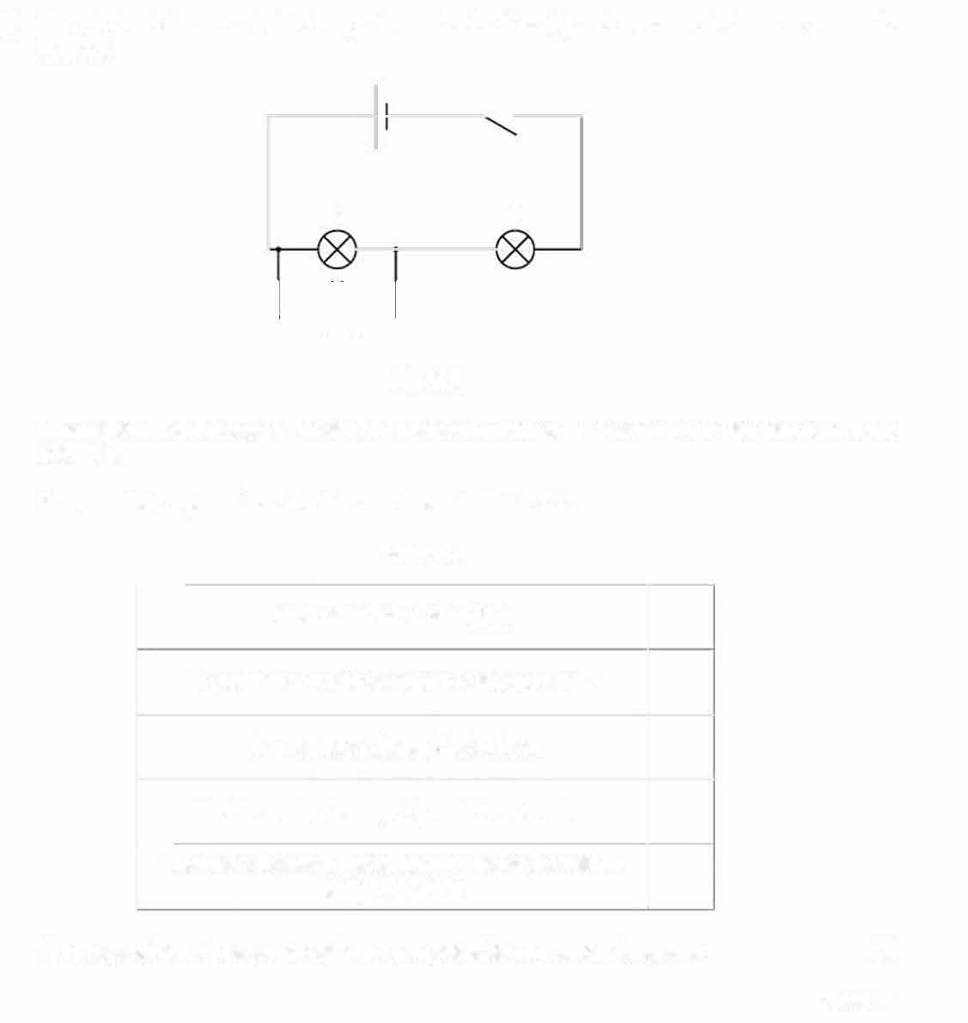
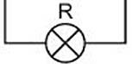
(b) The student disconnects the lamps from the circuit in (a) and reconnects them as shown in Fig. 4.1.

Q p

Fig. 4.1
When the switch is closed, the student notices that lamp Plights dimly and lampsQ and R do not light.
Five possible explanations for this are shown in Table 4.1.
Table 4.1
--
the cell needs recharging

the currents in lampsQ and R are too small
the filament of lamp ? is broken
the filaments of lampsQ and R are broken
-
there is a break in the lead connecting the cell to lampsQ and R

Place a tick in the boxes opposite the two possible correct explanations. [2]
[Total: 3]

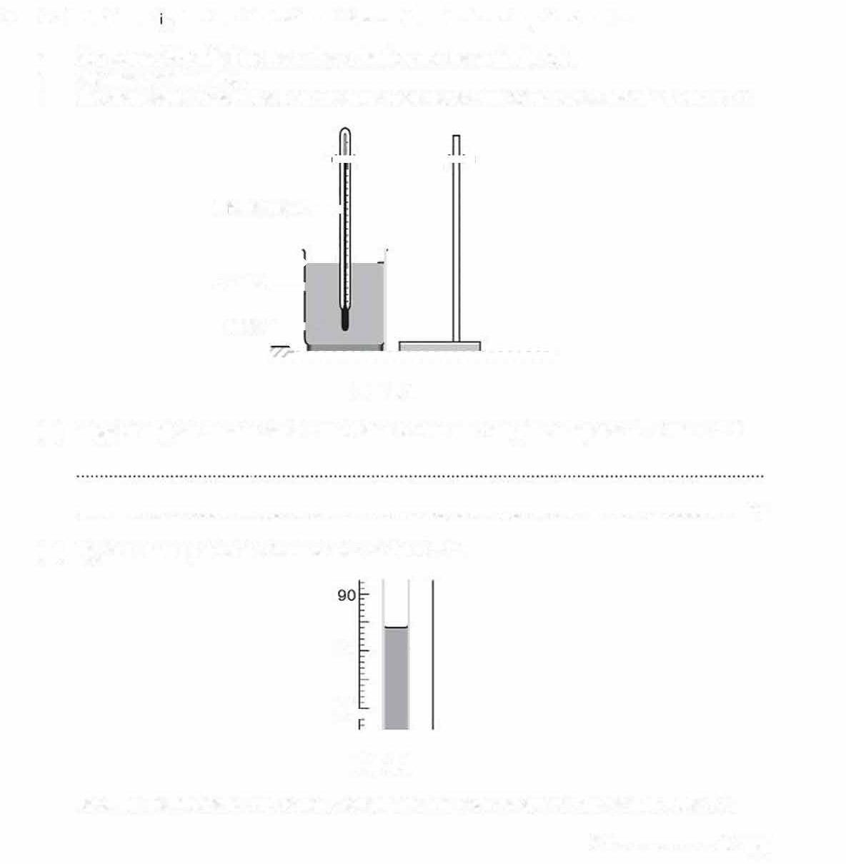
- A student investgates the effect of insulation on the rate of cooling of hot water.
  - She pours 200 cm3 of hot water into a beaker, as shown in Fig. 3.1.
  - She waits a short time.
  - She then starts a stop-watch and records the temperature of the water. This is at time I= 0.

thennometer-

beaker-water--<-

Fig. 3.1

- Suggest why the student waits a short time before recording the temperature at time I= 0.

...............................................·····..............................................·····. (1]

- Fig. 3.2 shows part of the thermometer at time t = 0.

80

70▸

Fig. 3.2
Read the thennometer and record the temperature 8 on the answer line and in Table 3.1.
e = .................... ·c 111

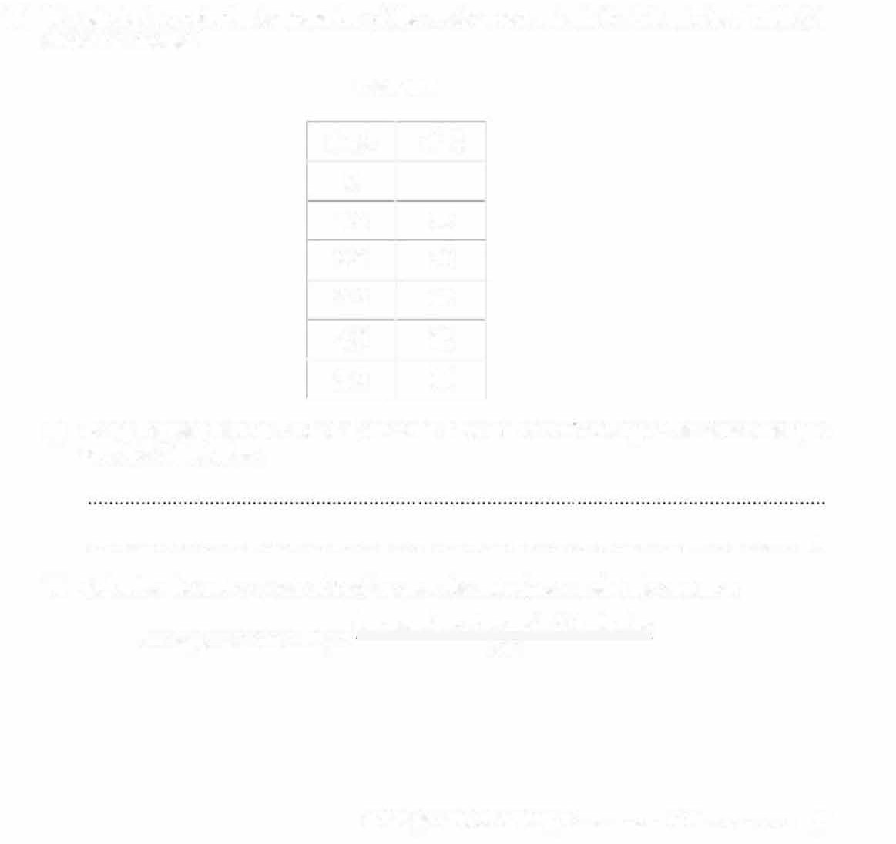
- The student records the temperature of the water every minute for 5.0 minutes. Table 3.1 shows her results.

Table 3.1

t/min | 01·c
0  1.0 | 76
2.0 | 70
3.0  4.0 | 65  62
5.0 | 61
  - Using the results from Table 3.1, describe how the rate of cooling of the water changes over the 5.0 minutes.

. [1]
  - Calculate the average rate of cooling over the 5.0 minutes using the equation: average rate of cooling= temperature change in 5.0 minutes
5.o

average rate of cooling= ................ unit [2]


- The student now covers the sides of the beaker with a layer of cotton wool and repeats the procedure, ensuring that the starting temperature is the same as the temperature recorded in (b).
Table 3.2 shows her rnew results.

Table 3.2
--
79
t/min  0 | et•c-
1.0
2.0 | 76
3.0  4.0 | 74  72
5.0 | 71-

  - Use the results in Table 3.1 on page 9 and Table 3.2 to suggest how the layer of cotton wool has changed the rate of cooling of the water.

. [1]

  - The student repeats the experiment again with the same starting temperature. Suggest how the student changes her apparatus to ensure that the temperature after 5.0 minutes
is greater than 71 •c.

. [1]

[Total: 7]

- A student investigates the magnetic field between two strong magl')etS.
She places the magnets as shown in Fig. 4.1.
•, �

IN :: sl s
adhesive putty

N

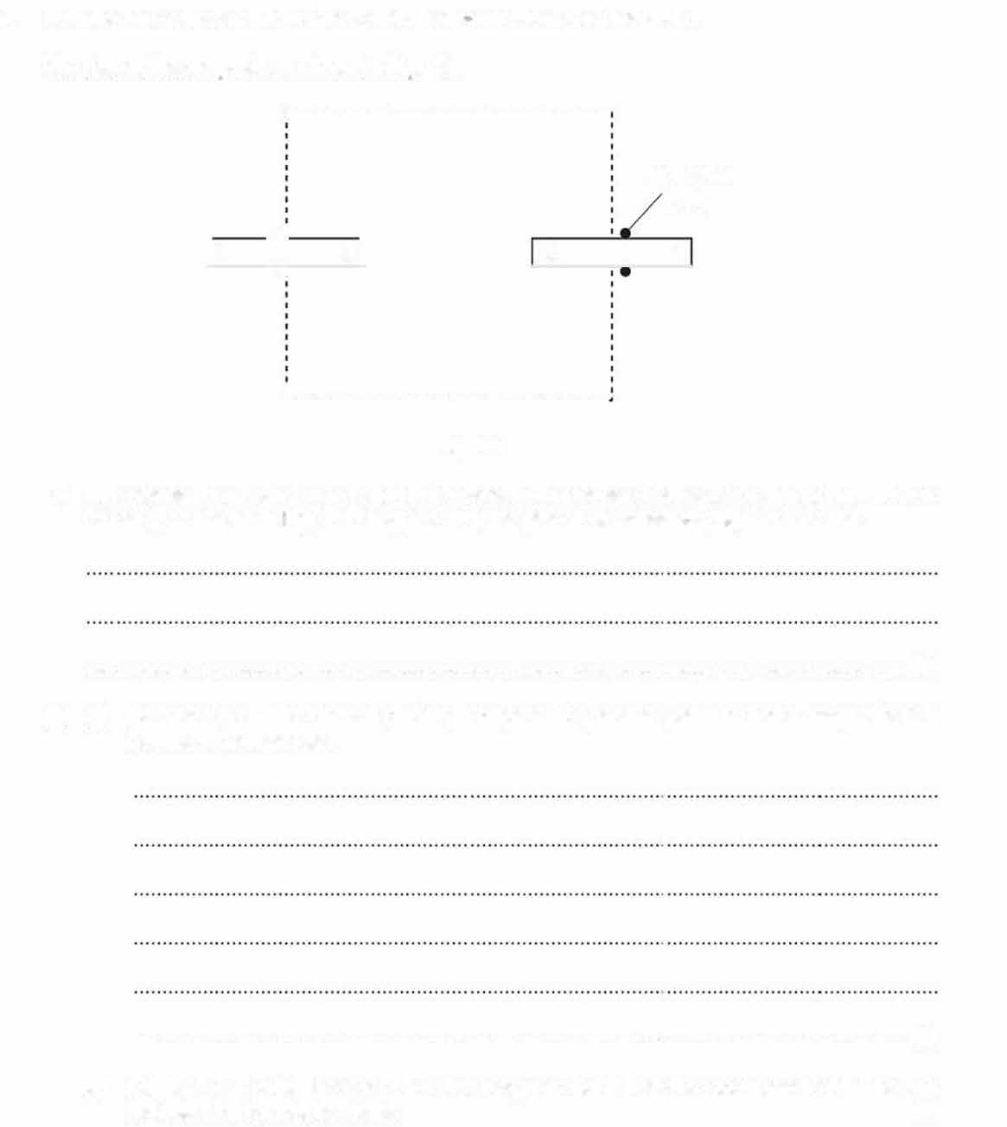

•·-----------------------------
Fig. 4.1

- She places the magnets on a smooth surface using pieces of adhesive putty (e.g. Blu Tack or Patafix), as shown in Fig. 4.1. Suggest why the pieces of adhesive putty are needed .

. [1]
- (i) Describe how she uses a plotting compass to plot the pattern of the magnetic field between the magnets.

. [3]
(ii) On Fig. 4.1, draw the shape of the magnetic field that she observes inside the box indicated by the dashed lines. [1]

- A student measures the acceleration of a trolley rolling down a ramp.
He makes a ramp by using a wooden plank, resting one end of the plank on a bench and using a stand and clamp :o support the other end.
He draws a line AB across the ramp near to the top.
  - He draws another line CO parallel to AB at a distanced= 12C.O cm further down the ramp.
He adjusts the height of the top of the ramp above the bench by moving the clamp until the ramp makes an angle of 30• with the bench.
He places a trolley on the ramp so that the front wheels of the trolley touch AB. Fig. 2. 1 shows the ramp set up by the student.

clamp

A

trolley
B---, d=120.0cm
_ - wooden plank

C 30

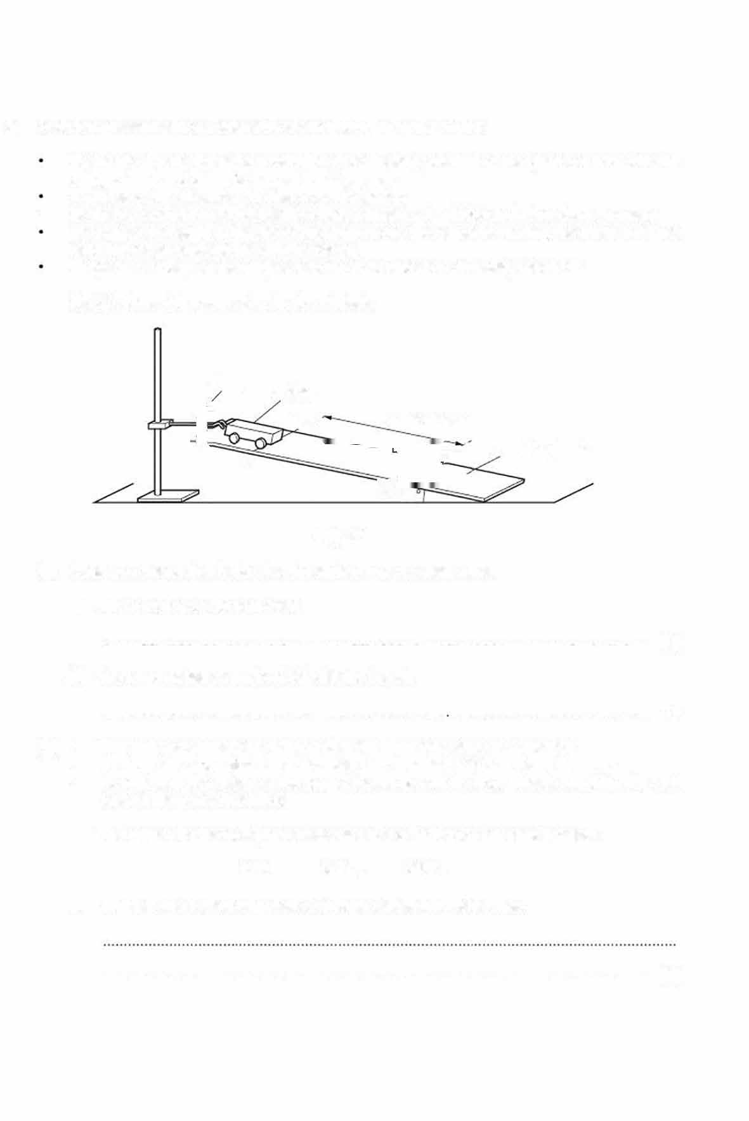
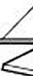
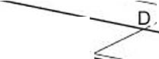
Fig. 2.1

- Suggest a measuring device that the student uses to ensure lhat:
  - AB and CD are 120.0cm apart
···············································""'"'·····"·"········"···"·····""·········"'"""'··· [1]
  - the ramp makes an angle of 30• with the bench.
.............................................. ..................................... ..······. [1]
- • The student releases the trolley and at the same time starts a stopwatch.
- He stops the stopwa:ch when the trolley has travelled 120.0cm down the ramp.
- He replaces the trolley at the top of the ramp with its front wheels touching AB and repeats the procedure twice.
The times I for the trolley to travel a distance d = 120.0cm are shown below.
0.70s 0.81 s 0.95s
  - Suggest one reason why there is a large variation in these times.

. (1]

  - Fig. 2.2 is a side view of the arrangement with the trolley at the start position.

On Fig. 2.2, draw the position of the trolley when it has travelled 120.0cm.

side view

Fig. 2.2
CD 30°

11]

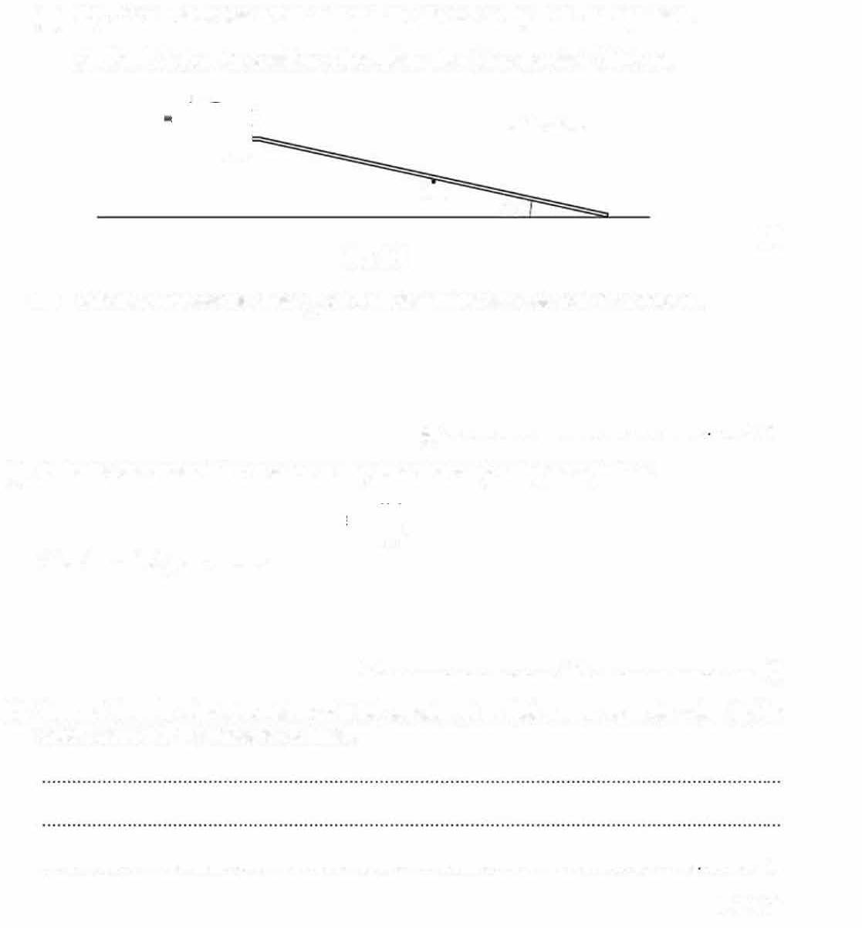
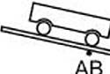
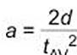
  - Calculate the average time IAv for the trolley to travel a distance d = 120.0 cm.

IAv = •sl1)
- Calculate the acceleration a of the trolley down the ramp using the equation:

Give the unit of your answer.

a = ................................ unit 12]

- Suggest how the student could modify his experiment so that a more accurate value for the acceleration a of the trolley is obtained.

................................................................................................................................. 11]
(Total: 8]

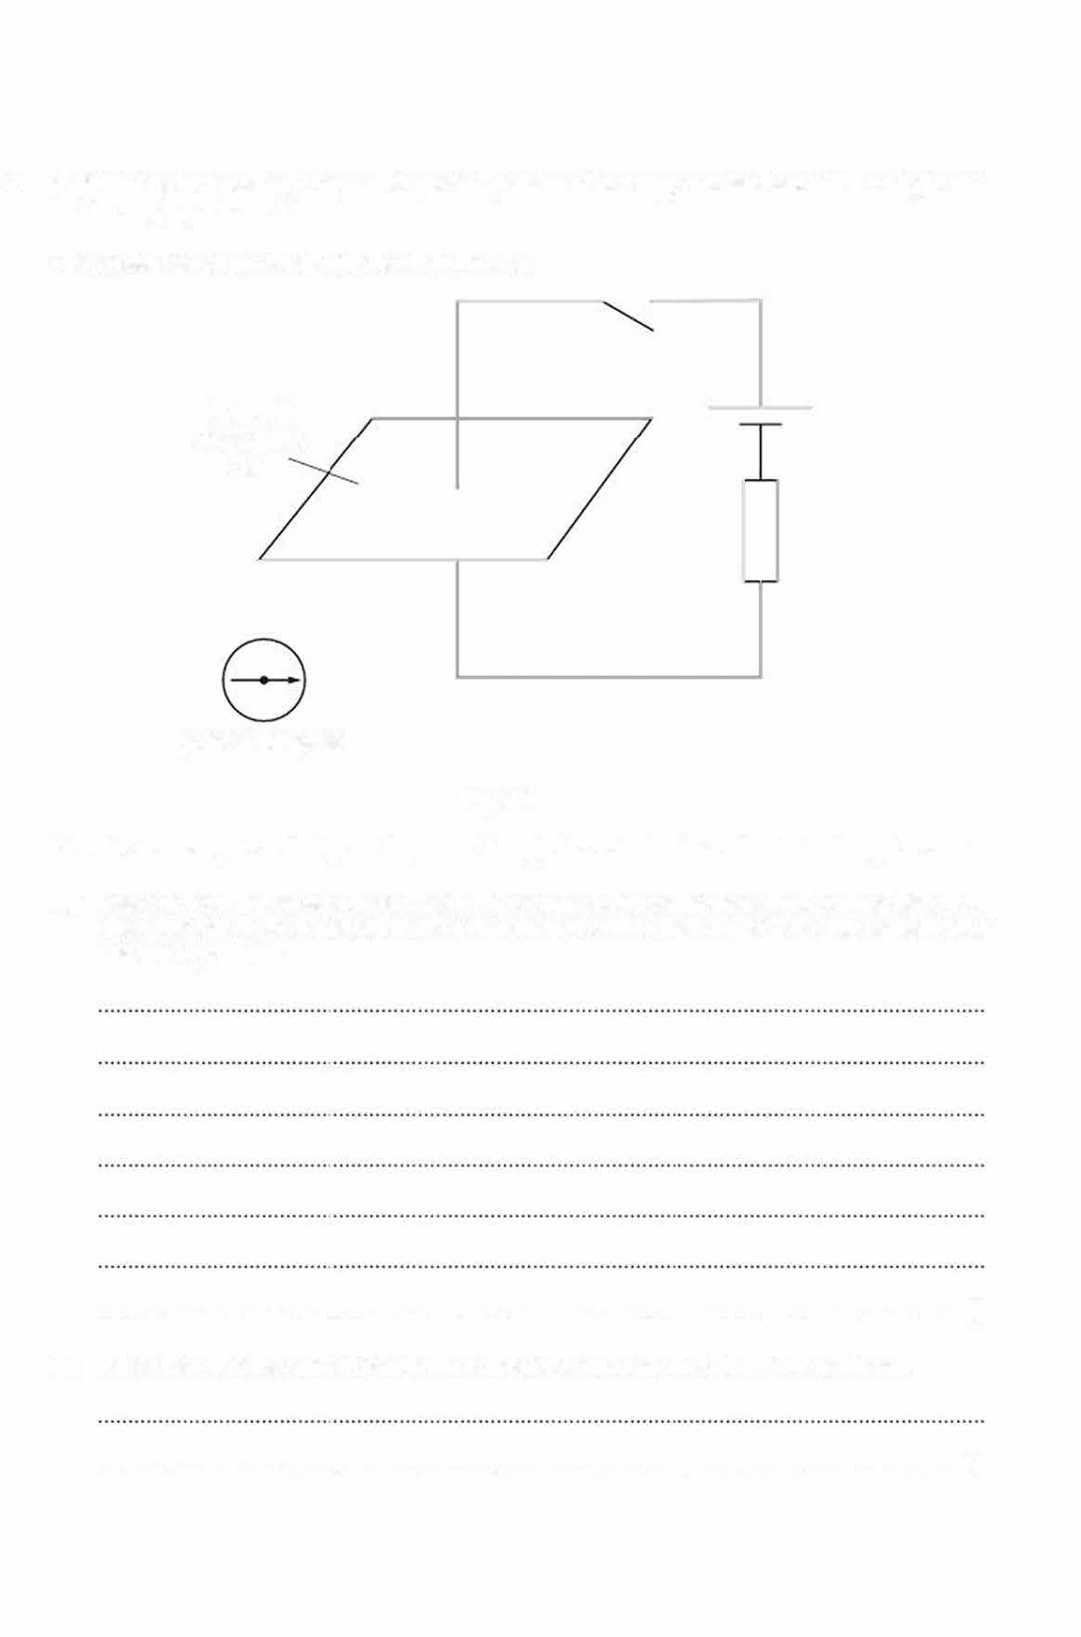
- A student uses a plotting compass to plot the pattern of the magnetic field around a straight wire that is carrying a current.

The student sets up a circuit, as shown in Fig. 4.1.

horizontal rectangular card

plotting compass

Fig. 4.1
The wire is arranged vertically and it passes through the middle of a horizontal rectangular card.

(a) Describe how the student uses the plotting compass to plot the pattern of the magnetic field when the switch in the circuit is closed. You may add to Fig. 4.1 to help you explain your answer, if you wish.

••••••••••••••••••••••••••••••••••••••••••••••••••••••••••••••••••••••••••••••••••••••••••••••••••••••••••••••••••••••••••••••••••••••••••••• [3] State what else the student can deduce about the magnetic field in this investigation.
{b)

. (1]

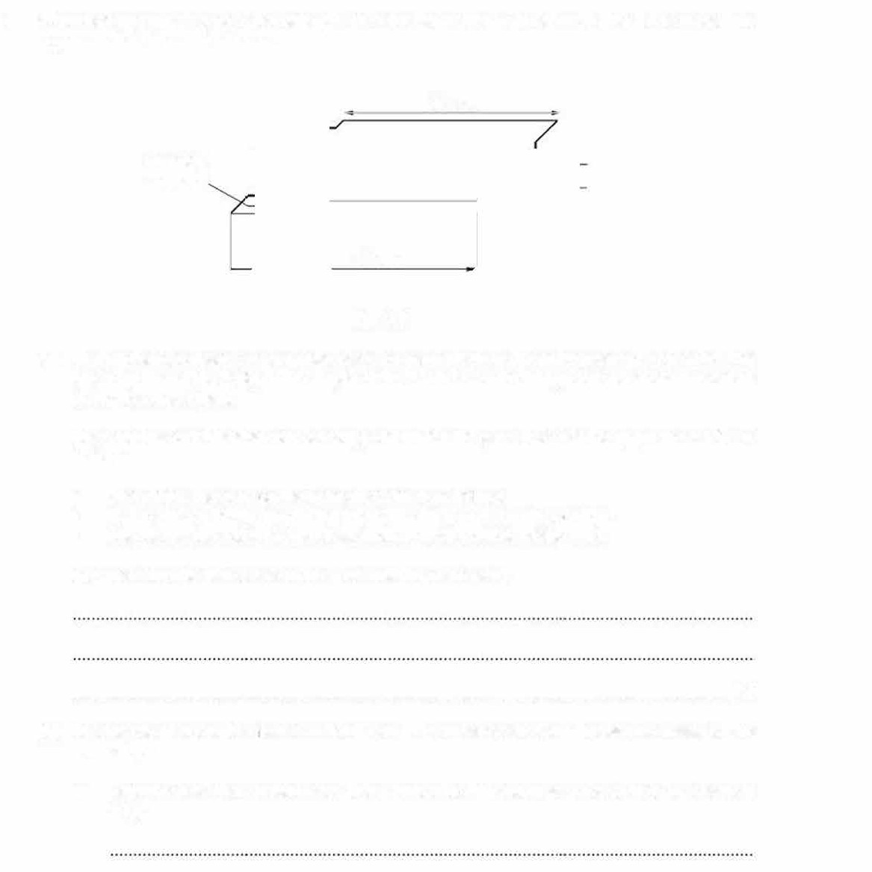
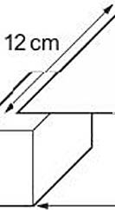
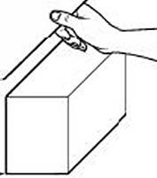
- A student investigates how the strength of a bridge varies with its width. Fig. 1.1 shows the apparatus that the student uses.

20cm

wooden support

16cm

Fig.1.1
- The student is given a rectangular piece of card which is 20cm long and 12cm wide. The card represents the bridge. The length of the card does not change but the width is reduced during the experiment.
She also has two identical wooden supports which are placed so that the gap between them is 16cm.
  - She places the card on the supports to make a bridge.
  - She loads the bridge by placing identical coins, one at a time, onto it.
  - She places the coins on top of each other on the middle of the card.

Suggest why she places the coins in the middle of the card.

. [1)

- She needs to know the 11ass of each coin. The balance available measures mass to the nearest gram.

- Describe how the student uses this balance to find the mass of a coin to the nearest
0.1 g.

- Each coin has a mass of 3.4 g.
  - She adds coins carefully, one at a t me, onto her bridge until the bridge collapses.
  - She records the number of coins that the bridge holds just before it collapses.
  - She repeats this four more times.
The number of coins needed is:

16 15 16 14 15

Find the average mass m in grams that the card can support. Give your answer to 2 significant figures.

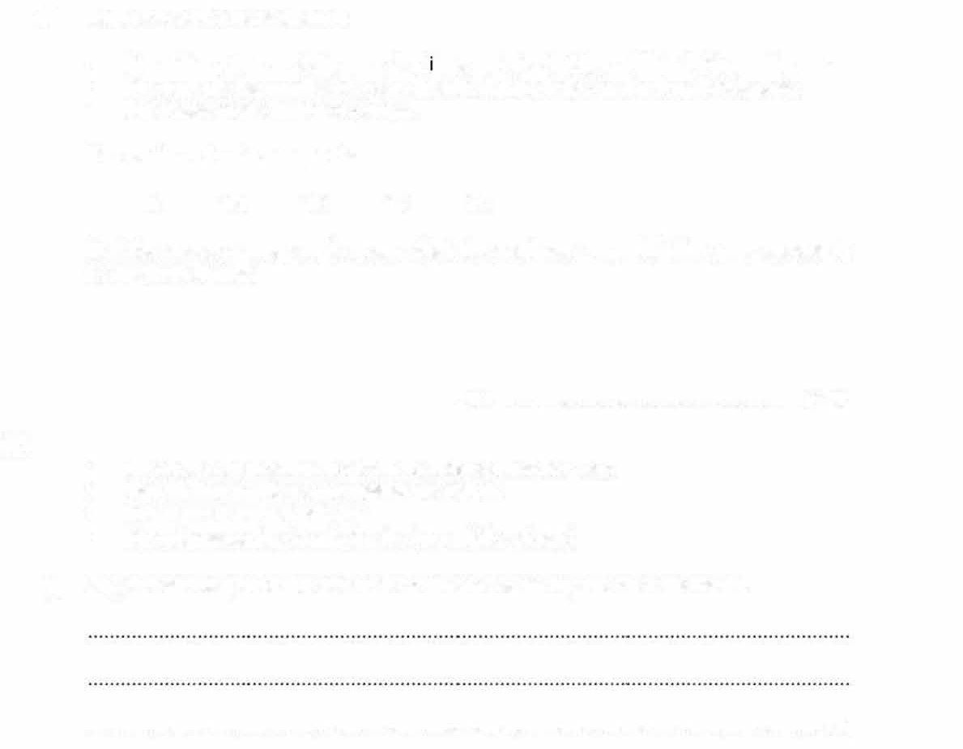

m = ...................................................... g [2)

  - She cuts a 2 cm wide strip from the long side of her card.
  - The width w of the card remaining is 10cm.
  - She repeats the experiment.
  - She compares the results for the two widths of card.
- Suggest one way in which her method allows a fair comparison to be made.

. [1 I

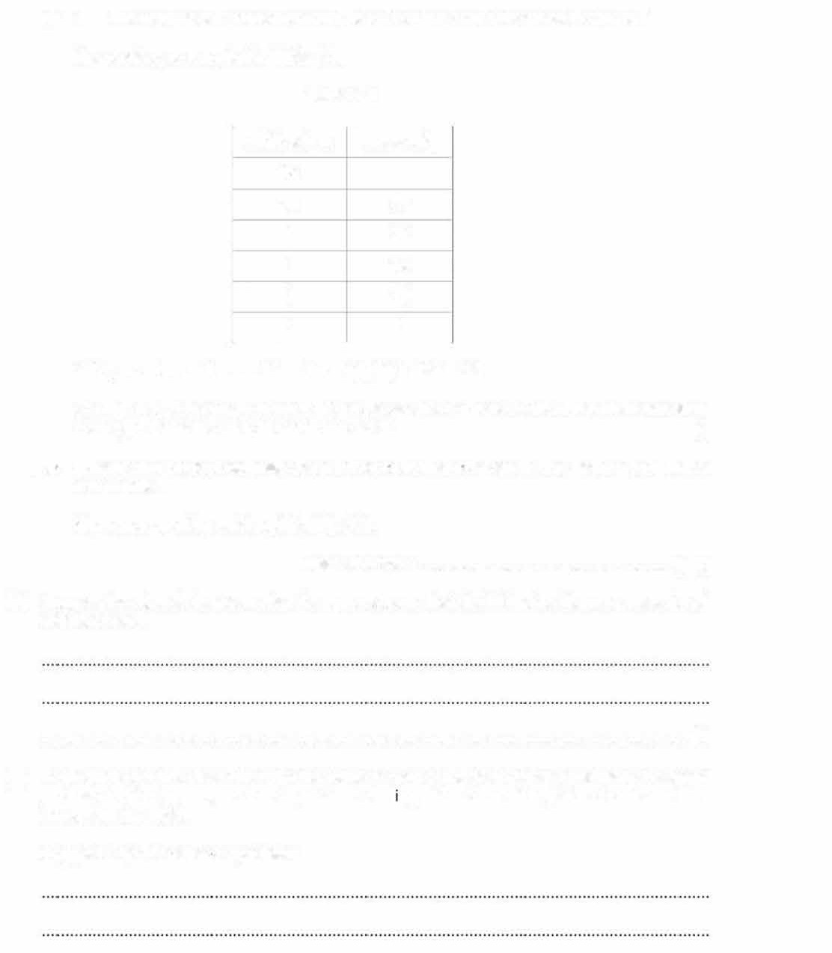
- She repeats this procedure until there is only a 2 cm wide piece of card left.

Her results are recorded in Table 1.1.

Table 1.1

width w/cm  12 | mass m/g
10 | 37
8 | 26
6 | 18
4 | 11
2 | 5
Add your value m for w = 12 cm from 1(b)(ii) to Table 1.1.
On Fig. 1.2, plot a graph of m on the y-axis against won the x-axis. Start both axes from the origin. Draw the smooth curve of best fit. [4]
(iii} Ex1end your curve to estimate the mass of coins that collapse the bridge for a card that is 13cm wide.
Show your working on the grid in Fig. 1.2.

mass of coins = ...................................................... g (2)

- Suggest how the student can alter the apparatus so that the bridge holds more mass for all widths of card.

. (1I
- Each student in the class has only one piece of card at the start of the experiment. A second student decides to carry out the experiment start ng with a 2 cm wide piece of card and 1hen increasing the width.

Suggest why this cause s a problem.

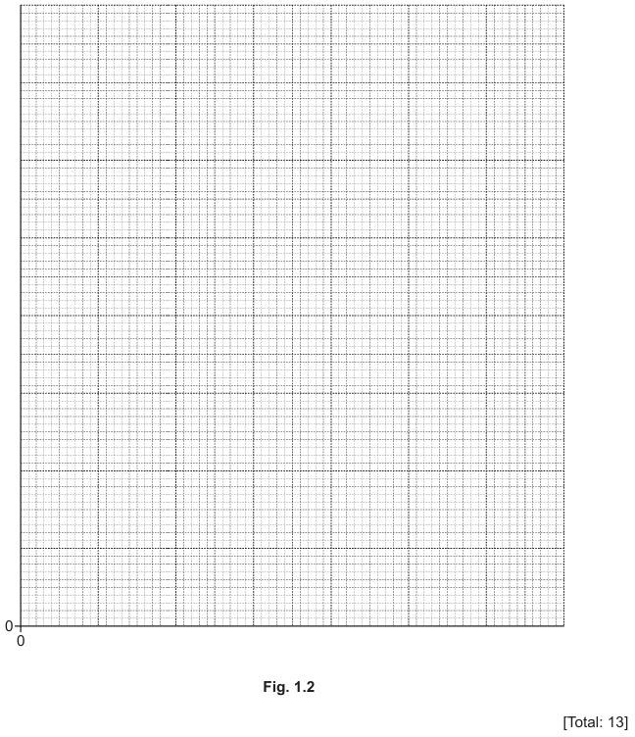

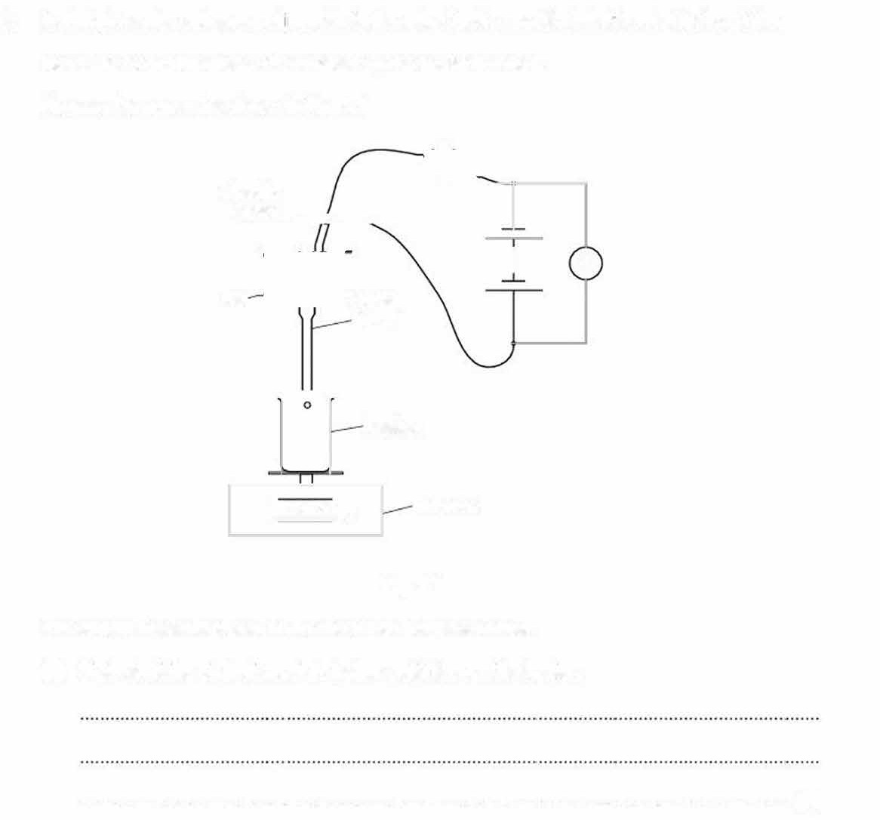
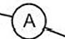
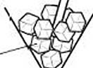
- A student carries out an experiiment to find a value for the specific latent heat of fusion of ice. He needs to find the mass of ice melted by the heater in time t.
He uses the apparatus shown in Fig. 2.1.

electric heater...___;.,,-�

: V
ice glass
funnel

o beaker

balance
I 239.4 I g

Fig. 2.1

The electric heater is placed in the ice inside the glass funnel.

- Siate what the student must do before switching on the heater.

. [11

- The heater is switched on and water drips into the beaker. The student switches off the heater after time t.
  - Suggest why the student waits a further minute after switching off the heater before taking a reading from the balance.

. (1)

  - The scales on the voltmeter and ammeter when the heater is switched on are shown in Fig. 2.2.

+O 2 3
0 0 5
+O
0 0 10
4 6

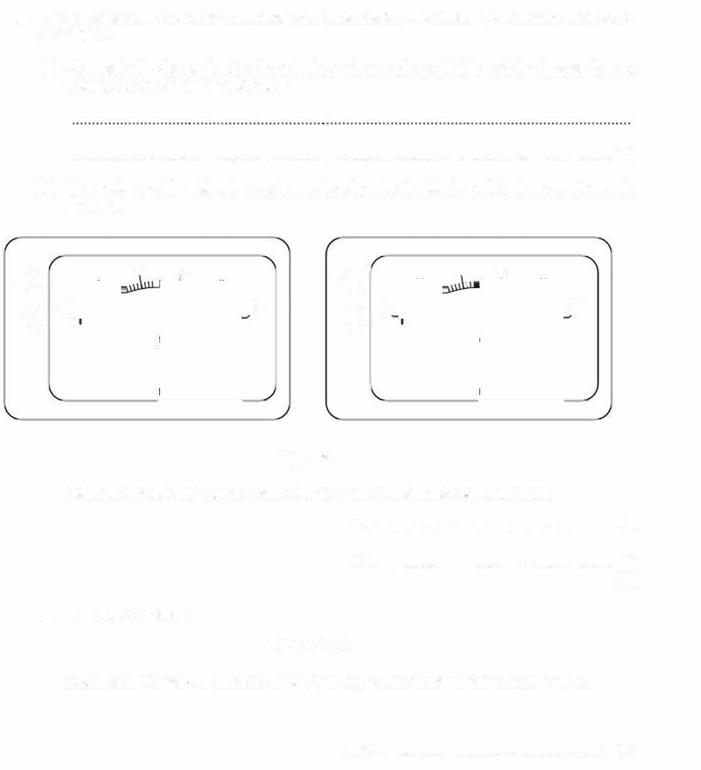
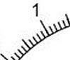
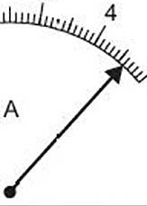
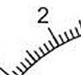
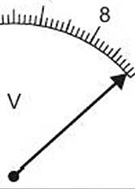

Fig. 2.2
State the reading of current I and voltage V when the heater is switched on.
I= A
V= V
[2]
  - Using the equation
E=fxVxt
calculate the energy E that has been supplied by the heater when t = 5.0minutes.
E = ...................................................... J [1)

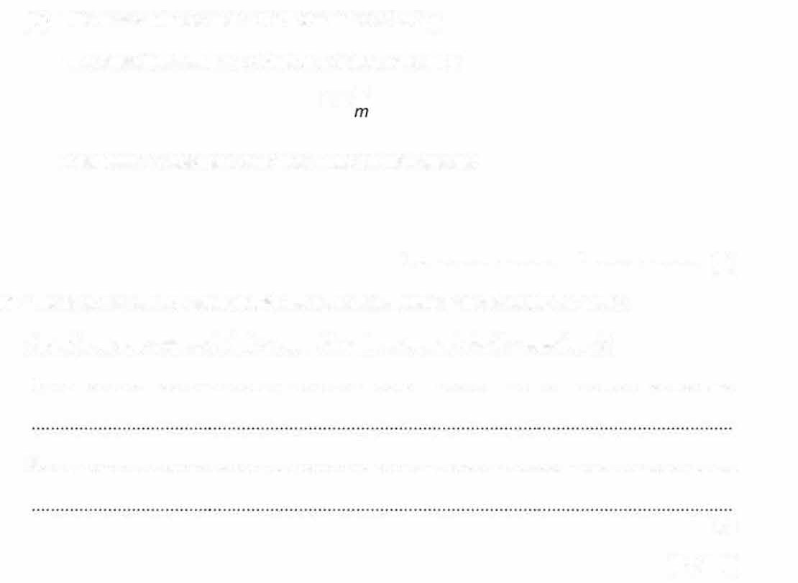
(iv) The mass m of ice melted in 5.0 minutes is 36.2 g.

The specific latent heat of fusion L of ice is given by
_{L} =£
Calculate a value for L and give a unit for your answer.
(c)
L = ......................... unit ...... ............ ....
The teacher tells the student that his value is different from the accepted value. Apart from your answer in (a), suggest two improvements to the experiment.
1 . ...............................................................................................................................................
[2)
2. ...............................................................................................................................................
[2)

[Total: 9)

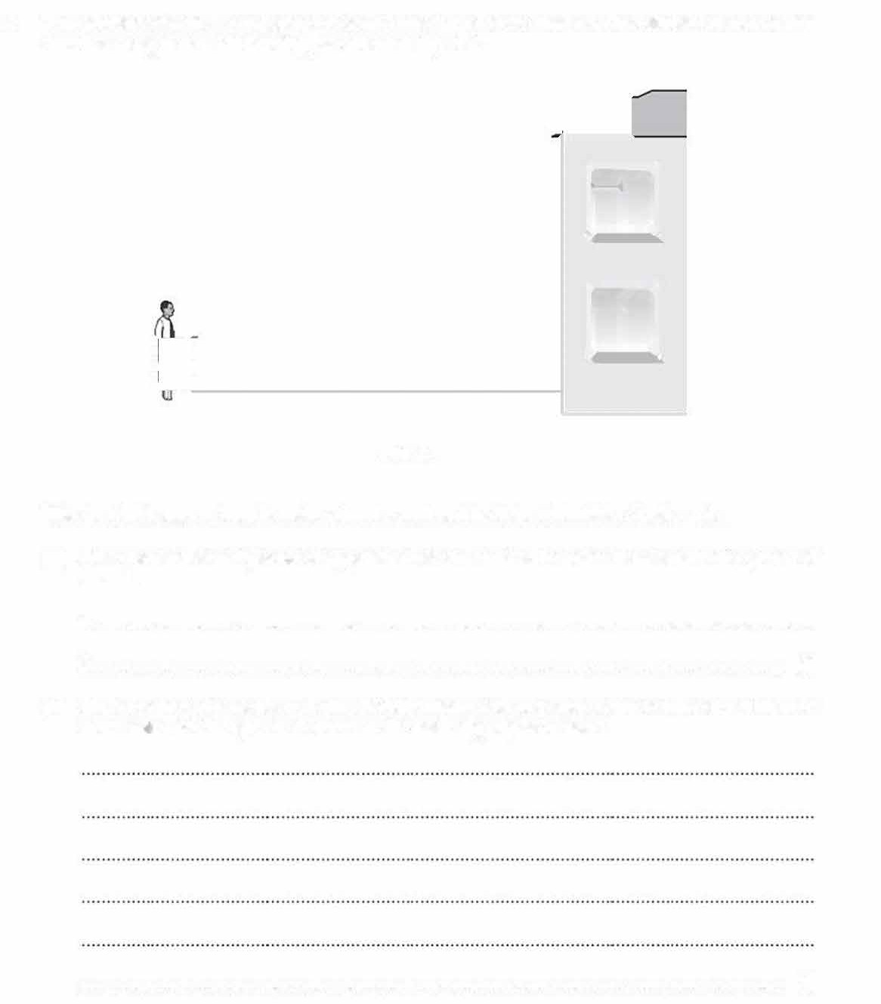
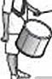
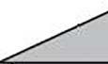
- Two students determine the speed of sound in air by an echo method. One student stands a long distance away from a tall building, as shown in Fig. 4.1.
fD ED

Fig.4.1

This student bangs a drum to make a loud sound and both students listen for the echo.

- State two additional pieces of apparatus that are needed in order to determine the speed of sound.

1 . ...............................................................................................................................................

2 [2)

- State the measurements that the students make and how they carry out the experiment to find a va ue for the speed of sound in air. State any equation used.

. [3)

- A student investigates reflection and refraction of light using a semi-circular glass block.
  - He places a glass block on a sheet of paper.
  - He draws around the outline of the block with a pencil.
  - He uses a ray box to direct a ray of light onto the centre C of the flat face AB of the block.
  - He labels AB and point C.

Fig. 3.1 shows what the student observes.

emergent ray

--'<---semi-circular
glass block

A

ray box

incident ray
B
refracted ray reflected ray

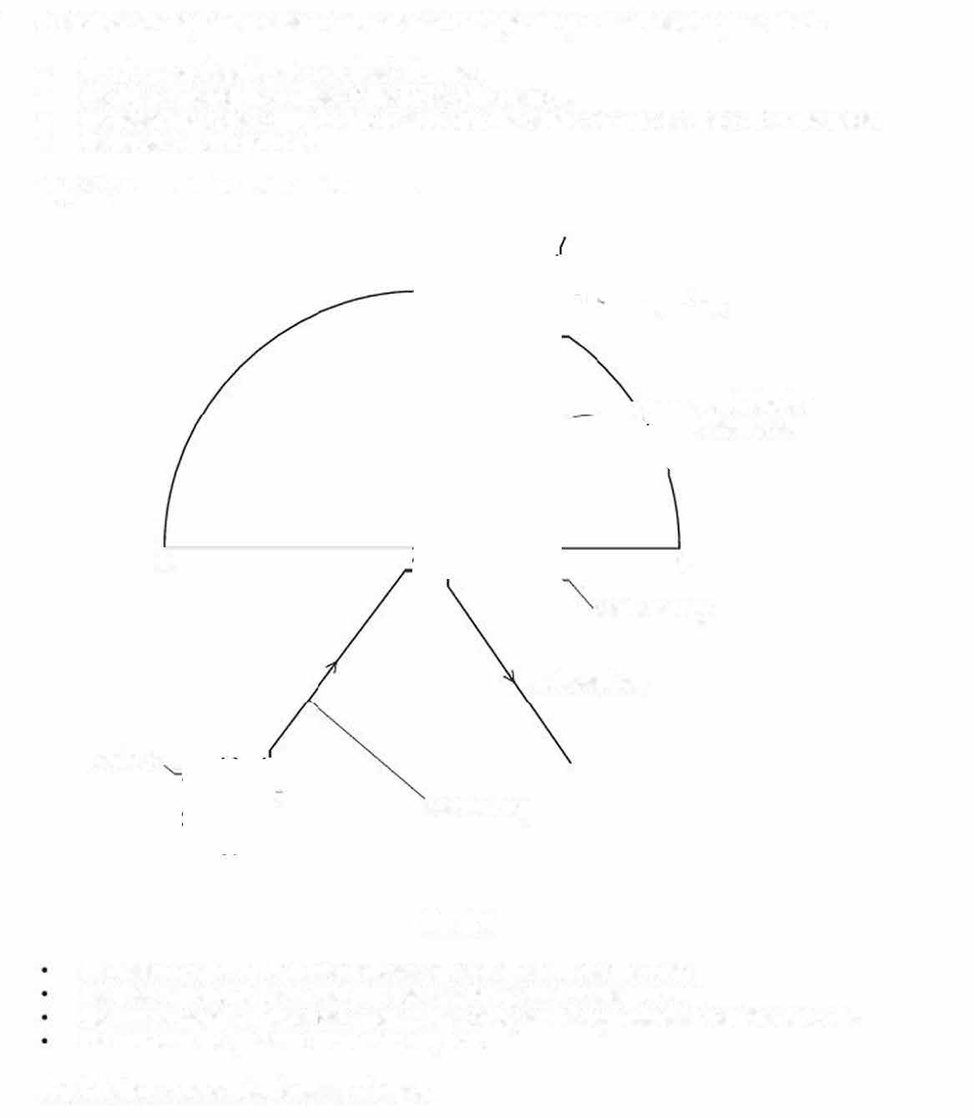
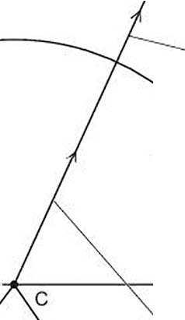
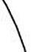
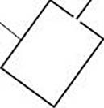

Fig. 3.1

He uses a pencil to place two crosses X₁ and X₂ on the incident ray. He uses a pencil to place two crosses x₃ and X₄ on the emergent ray.
He uses a pencil to place two crosses X₅ and X₆ on the ray reflected from the face AB.
He removes the glass block and the ray box.

Fig. 3.2 shows the student"s sheet of paper.

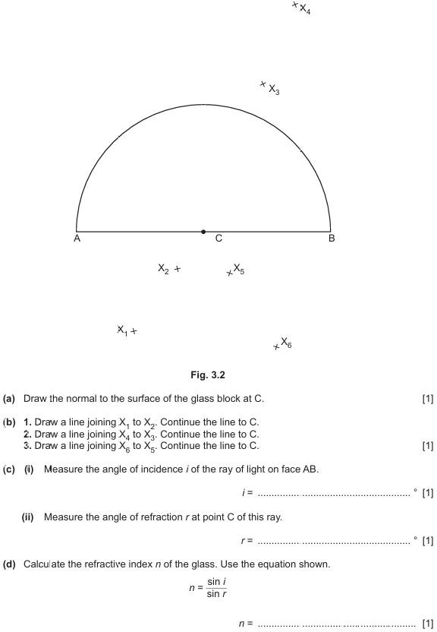

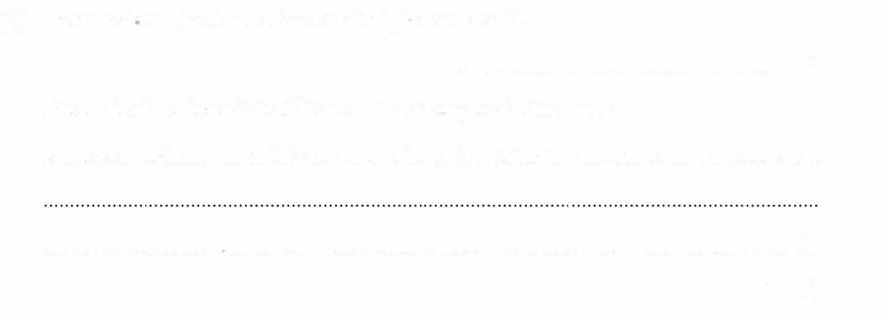
(e) Measure the angle of reflection R of the light from face AB.
R= o

The angle of incidence i should be equal to the angle of reflection R.

State one practical reason why the angles i and R that you have measured may not be equal.
....................... ... ........... . ....... ........... ...... . ................. . ... ................ .................................. .......
[Total: 6]
[1]

